[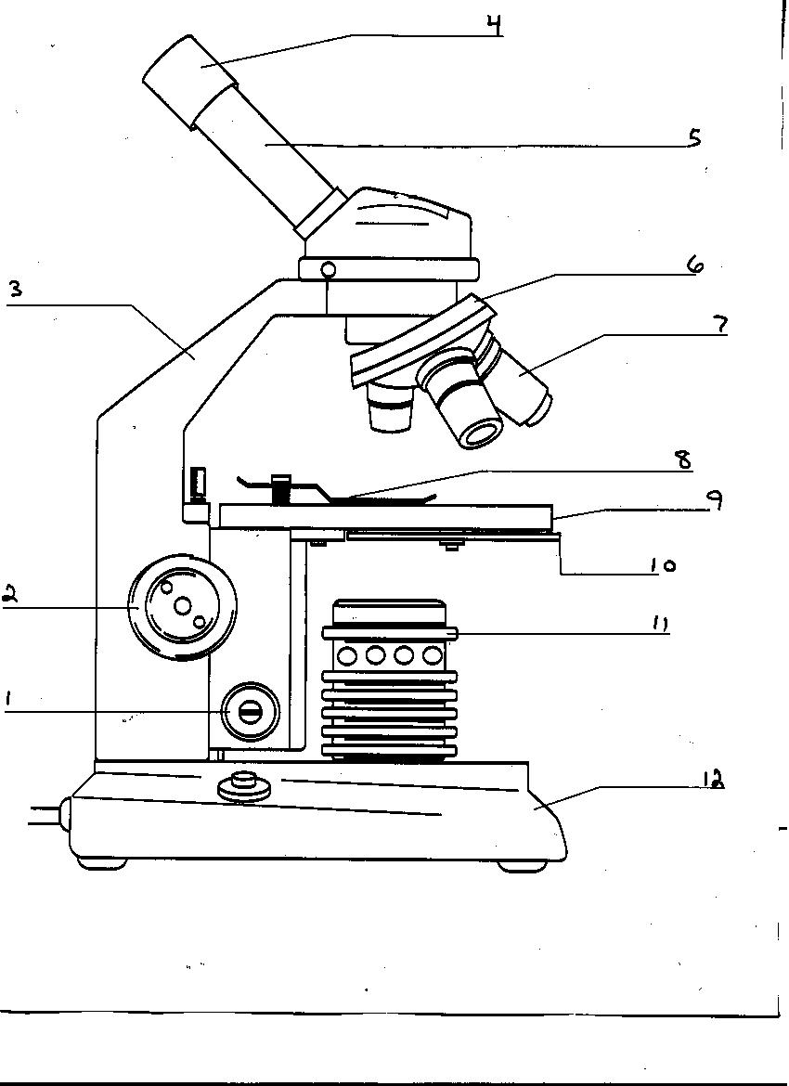](http://www.google.com/url?sa=i&rct=j&q=microscope+diagram&source=images&cd=&cad=rja&docid=wWWKP2XmRXdqyM&tbnid=rNV7MGjEwjx8HM:&ved=0CAUQjRw&url=https%3A%2F%2Fpiperpages.wikispaces.com%2FBlank%2BMicroscope%2BImage&ei=2pUCUuL-NOjUyQGyjIC4Bg&bvm=bv.50310824,d.aWc&psig=AFQjCNE3AS_xyti9w11uVyisig-0QdALQA&ust=1375987523477531)