Honors Biology Name: _______________________
NDSH Per: _________ Date: ___________
Polypeptide Synthesis
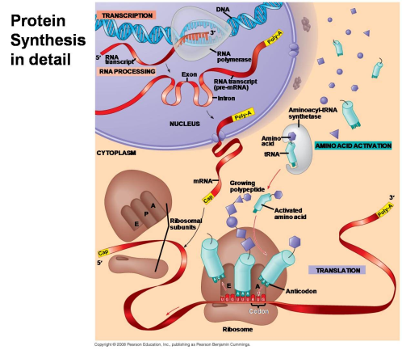
DNA controls the cell by directing the manufacture of .
Proteins are made up of .
Amino acids are held together by chemical bonds called . Thus a long chain of amino acids is also called a .
(Remember: Proteins are digested in the stomach by the enzyme PEPSIN.)
Three Main Steps of Polypeptide (Protein) Synthesis
- __________________________________________________
Three types of RNA are made:
  - ________________________________
  - ________________________________
  - _______________________________
- is altered to its final form = ______________
- ___________________________________________________________________________
BACKGROUND:
RNA Structure:
- _________________________
- _____________ instead of _____________
- _____________ instead of _____________
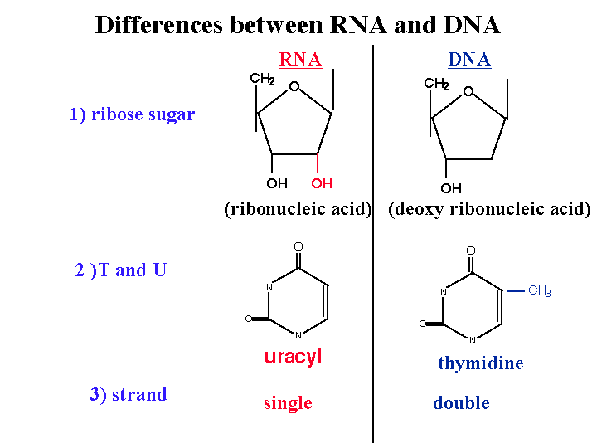
mRNA Structure:
- _______________
- _______________
- _______________________ of nucleotides long
- 5’ end gets capped with a _____________________________
- 3’ end gets a long tail of _____________
tRNA Structure:
- about _____ nucleotides long
- attaches to itself and forms ___________________ sections and then
- 3’ end is where the for the process of translation
- in the middle of the tRNA is a three segment nucleotide sequence called the
- this nucleotide sequences which are called the
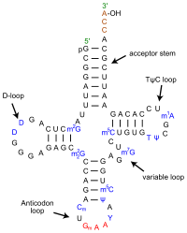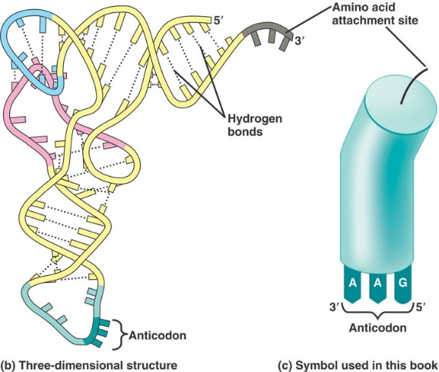

rRNA Structure:
- rRNA combines with proteins in the nucleolus to form two ribosomal structures: _____________________
- small subunit holds the
- large subunit holds the to make the amino acid chain (protein)
- the where the
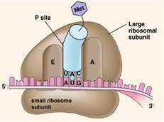

Polypeptide Synthesis: The Details
- Transcription:
WHERE:
WHAT:
HOW:
- _____________________________________________
- __________________________________________________________________
- ________________________________________________________________
_________________________________________

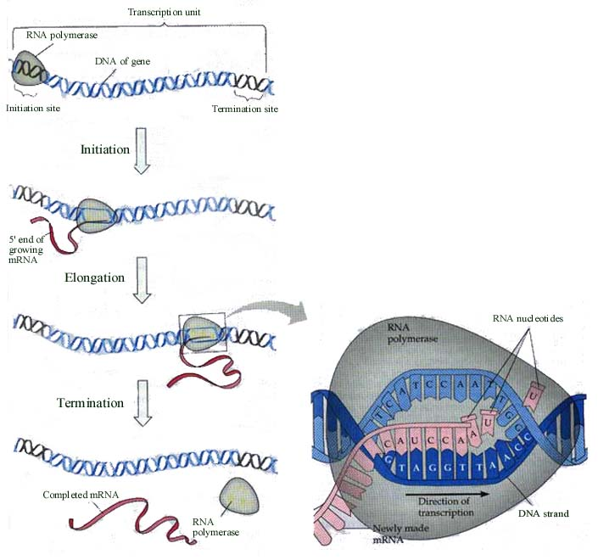
- RNA Processing:
WHERE:
WHAT:
HOW:
tRNA folds into its correct shape
rRNA goes to nucleolus to become the ribosome
mRNA undergoes three main changes
- ______________________________________________ – this is called the __________
- ________________________________ – lots of adenines are added – helps ________________________________
- ________________________________________
DNA contains two types of nucleic acid sequences in a gene.
________: nucleotides that will be _____________________
________: nucleotides that .
________________________________________________________________________________________
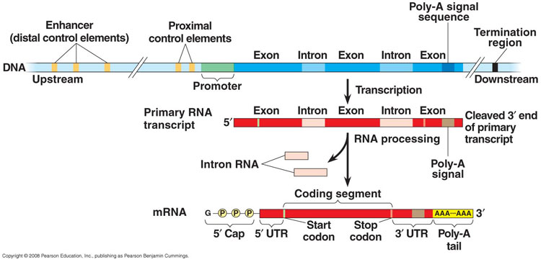
- Translation:
WHERE:
WHAT:
HOW:
The whole system is based on the .
DNA is called the .
Three nucleotide sequences in mRNA are called .
Three nucleotide sequences in tRNA are called __________ – the anti-codon is complementary to the codon, which is complementary to the code.
- _______________________________________________
– directed by enzymes
- ______________________________________________________________
- _______________________________________________ _________________
The first three nucleotides of every . This codes for the amino acid ________________.
- The
- The .
- Determine the – use mRNA codon chart.
- _____________________________________________________________________________________________________________________________________.
- ____________________________________________________________________________________________________________________________________________.
- the tRNA in the ________________________________
- the tRNA in ___________________________________
- This process (steps 5 – 7) repeats over and over building the amino acid chain _____________________________.
- STOP codons = _____________________
- bring in a protein called a ________________ and this causes the ________________________________ and the ribosome to detach from the mRNA.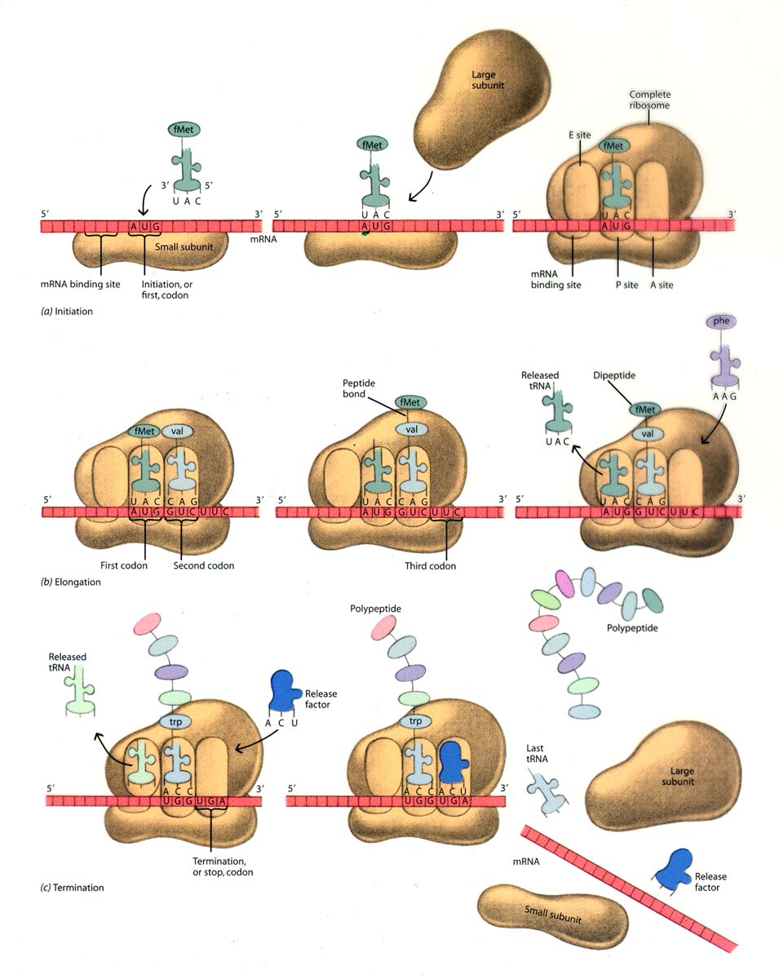

Determining the Amino Acid Sequence Based on the mRNA Codon
Step 1: Transcribe the DNA into RNA
Step 2: Use Codon Chart to determine the amino acid brought in by tRNA
DNA CODE: TAC GAA CTG TGC GGG CCA ATC
mRNA CODON: ______ ______ ______ _____ ______ _____ _____
AMINO ACID: ______ ______ ______ _____ ______ _____ _____
