Honors Biology Name: _________________________
NDHS Per: _______ Date: _______________
Plant Transport
Plant: terrestrial (mostly), multicellular, photoautotrophic, eukaryote, true tissues and organs
Plant Structure:
Tissue Basic Tissue Types: give rise to specialized cells
________ - outer coat – ________
________ – ________________
________ – between Dermal and Vascular
______________ __ :
- ________
Function: ___________: secretes the _____________________________
________________:
________: ________________– unidirectional (up)
________: ________________– bidirectional
________________:
- Occupies the space between the vascular tissue and the dermal tissue
Functions:
________– roots and stems
________– stems
________________– leaves and some stems

Plants Roots, Leaves, and Stems:
Roots:
Functions:
- ________________________________________________
- ________________________
- ________________________
- ________________________
Stems:
Function:
- ________leaves and flowers
- ________ ________ (non-woody plants – herbaceous)
- ________: food (tubers – potato) and water (cactus)
Leaves:
Functions:
- ________________
- ________ (succulent leaves, Aloe)
- ________________: spines, toxins, trichomes
- ________________: flowers (modified leaves)
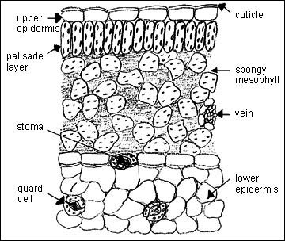
Transpiration:
  - Transpiration: ________________________________________________________
  - regulation of the ________________________________________by the ________________________________
- Proper ________________________________________from the air spaces in the spongy mesophyll
- ________________________which gets the water ________________
- Transpirational pull results from the properties of _____________________
  - As one water molecule moves out of the xylem ________________ ________________ because they are ________________________ ________________
  - Water does not move down the xylem because it is ____________ ____________________________________
  - 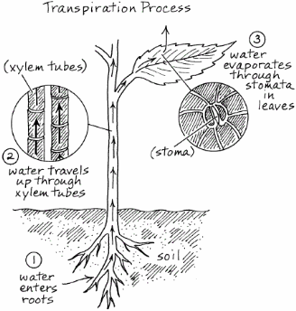
- Factors Affecting Transpiration:
Temperature: ________________
Humidity: ________________
Air flow (wind): ________________
Regulation of Transpiration
- ________________: Regulate the ________________________– responsible for the photosynthesis/transpiration compromise
Anatomy of Guard Cell:
  - ________ ________ ________ ________ (stomatal side is thicker)
Physiology of Guard Cell:
- ________________________________of the guard cell from surrounding cells
- ________________________________More water causes the ________ ________
- Uneven thickness of the cell wall causes the _______________________
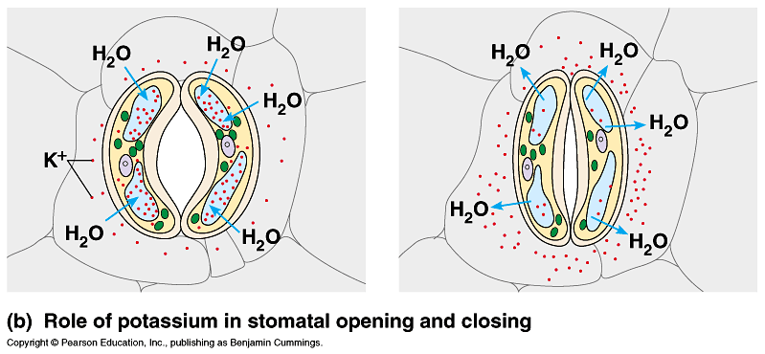

Translocation in Phloem
- Movement from ____________
  - ________: Location of ________________
    - Photosynthesis: ________________________
    - Starch Metabolism: ________________________
  - ________: Location of ________________________________
    - ________________
    - ________________________________________
- Sugar is produced and ________________________
- ________________________
- ________________________inside of the cell
- ________________________through the cells to the sink
