Honors Biology Name: _________________________
NDHS Per: _______ Date: _______________
Plant Transport
Plant: terrestrial (mostly), multicellular, photoautotrophic, eukaryote, true tissues and organs
Plant Structure:
Tissue Basic Tissue Types: give rise to specialized cells
Dermal - outer coat – protection
Vascular – transport tubes
Ground – between Dermal and Vascular
Dermal Tissue:
- Epidermis
Function: protection: secretes the cuticle (waxy coat on leaves)
Vascular Tissue:
Xylem: Water movement – unidirectional (up)
Phloem: Sugar movement – bidirectional
Ground Tissue:
- Occupies the space between the vascular tissue and the dermal tissue
Functions:
Storage – roots and stems
Support – stems
Photosynthesis – leaves and some stems

Plants Roots, Leaves, and Stems:
Roots:
Functions:
- absorb water, nutrients and minerals
- anchor plant in soil
- store food and water
- support the plant
Stems:
Function:
- support leaves and flowers
- photosynthesis (non-woody plants – herbaceous)
- storage: food (tubers – potato) and water (cactus)
Leaves:
Functions:
- photosynthesis
- storage (succulent leaves, Aloe)
- protection: spines, toxins, trichomes
- reproduction: flowers (modified leaves)
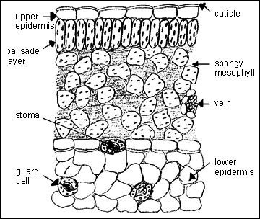
Transpiration:
- Transpiration: Moving water from the roots to the leaves through the xylem
  - regulation of the photosynthesis/transpiration compromise by the guard cells and stomata
- Proper gas exchange causes the loss of water from the air spaces in the spongy mesophyll
- pulls water out of the mesophyll which gets the water from the xylem
- Transpirational pull results from the properties of cohesion and adhesion
  - As one water molecule moves out of the xylem it tugs on the water molecule behind it because they are bound to each other (cohesion).
  - Water does not move down the xylem because it is sticks to the sides of the xylem (adhesion).
  - 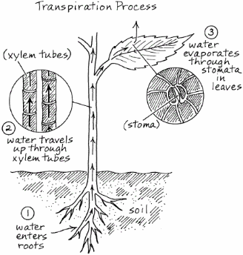
- Factors Affecting Transpiration:
Temperature: Hotter = more
Humidity: Higher = less
Air flow (wind): Higher = more
Regulation of Transpiration
- Guard Cells: Regulate the size of stomata for gas exchange – responsible for the photosynthesis/transpiration compromise
Anatomy of Guard Cell:
  - unevenly thickened cell walls (stomatal side is thicker)
Physiology of Guard Cell:
- Potassium ions are pumped into the vacuole of the guard cell from surrounding cells
- Higher concentration of K+ causes an influx of water
- More water causes the cell to swell
- Uneven thickness of the cell wall causes the cell to curve and open
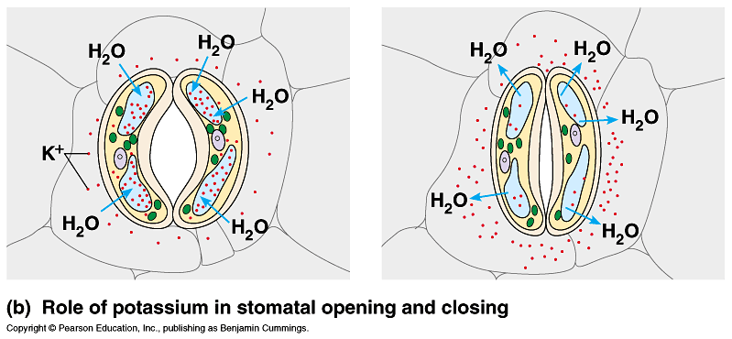

Translocation in Phloem
- Movement from Source to Sink
  - Source: Location of Sugar Production
    - Photosynthesis: Leaves (summer and fall)
    - Starch Metabolism: Roots (spring)
  - Sink: Location of Sugar Consumption or Storage
    - Fall (Roots)
    - Spring (buds for leaf and stem growth)
- Sugar is produced and pumped into phloem
- Water follows the sugar
- Builds pressure inside of the cell
- Pushes the solution through the cells to the sink
