Honors Biology Name: _________________________
NDHS Per: _________ Date: _____________

Photosynthesis
Meaning:
Synth = ______________________
Photo =

Importance:
(organisms that make their own food) into for themselves and ___________________(organisms that eat other things).

Equation:
_________________________________________________
Location: in the cells of producers
Ex:
In plants and algae photosynthesis occurs in the .
Chloroplast Structure:
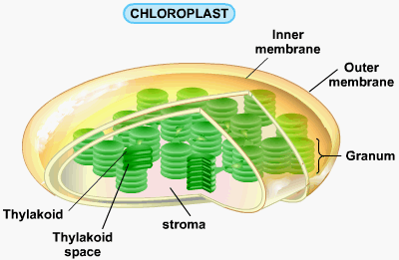
Process of Photosynthesis
Two Main Steps:
- ____________________________________________: Light is used to ____________________________________________________________ __________________________________________________
Occurs in the
- _____________________________________________: Energy in ATP and NADPH are used to _________________________ Occurs in the
Light Dependent Reaction:
Occurs in the Thylakoid of the Chloroplast
Structure of the Thylakoid:
Thylakoid Membrane and Thylakoid space
Thylakoid Membrane Contents:
- ________________for _____________light energy
Primary Pigment: _______________
- Two forms: Chlorophyll a and Chlorophyll b – slight different in molecular structure – allows them to absorb _________________ of light
- Chlorophyll absorbs __________________________________
Secondary Pigments: in a lesser abundance in the thylakoid so not as apparent
- _________________________________________________
- – yellow and orange pigments
All the pigments make up an called a
that it into one area.
- _______________________________
- series of that
- ____________________________: use the energy from electrons to ____________________________ from the
- ___________________________: an enzyme that puts electrons, hydrogen ions, and NADP+ together to
- __________________: An enzyme that makes
NADP+/NADPH:
Nicotinamide Adenine Dinucleotide Phosphate – is a
This is a that
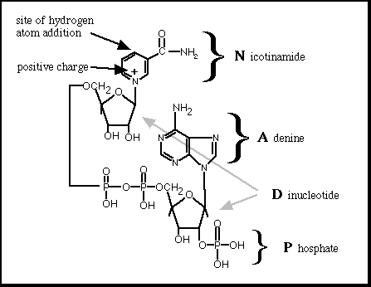
ATP is
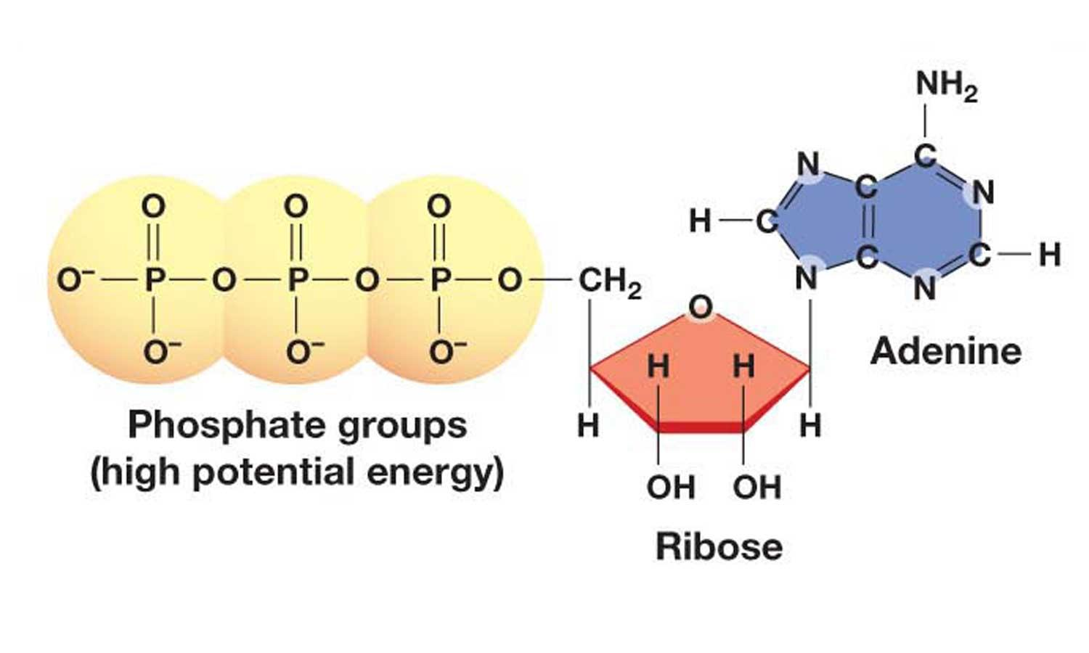
ATP in the Phosphate bonds when a phosphate is bound to ADP (adenosine diphosphate)
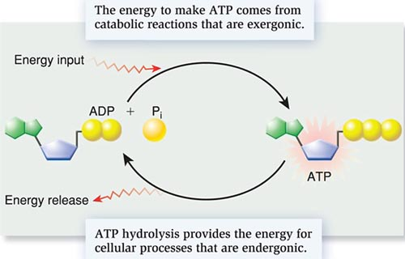
Steps of the Light Dependent Reaction
1) In the thylakoid space,
Oxygen diffuses out of the chloroplast and out of the leaf through the ________________
2) The
3) The electron passes through the and gives energy for the transmembranal proteins to from the
4) The electrons are at a photosystem and then pass to where they join a hydrogen ion and NADP+ to make ______________
5) The hydrogen ions that have been pumped into the thylakoid space have built _____________________________________________________________________________________________________
The ATP and NADPH are then used in the Light Independent Reaction

Light Independent Reaction
Occurs in the of the chloroplast
Called the “ ” reaction because it , but can occur in the light.
Also known as the
Requires:

Process of Light Independent Reaction
______________________________________________________________________________________________________________________________________
This occurs forming with three carbons each. These are then joined to make .

Summary:

