Honors Biology Name: _________________________
NDHS Per: _________ Date: _____________

Photosynthesis
Meaning:
Synth = to put together
Photo = light
To put together using light
Importance:
Producers (organisms that make their own food) fix (trap) light energy into biological molecules for themselves and consumers (organisms that eat other things).
Basis of all energy for all organisms
Equation:
6 H₂O + 6 CO₂ 6 O₂ + C₆H₁₂O₆
Location: in the cells of producers
Ex: Plants, Algae, Cyanobacteria (blue green algae)
In plants and algae photosynthesis occurs in the chloroplast.
Chloroplast Structure:
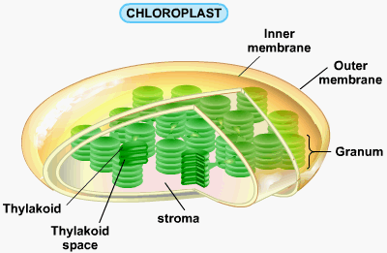
Process of Photosynthesis
Two Main Steps:
- Light Dependent Reaction (Light Reaction): Light is used to break water into hydrogen, oxygen, and energized electrons. Energized electrons are used to make ATP and NADPH.
Occurs in the Thylakoid
- Light Independent Reaction (Dark Reaction): Energy in ATP and NADPH are used to FIX carbon into glucose Occurs in the Stroma
Light Dependent Reaction:
Occurs in the Thylakoid of the Chloroplast
Structure of the Thylakoid:
Thylakoid Membrane and Thylakoid space
Thylakoid Membrane Contents:
- Pigments for absorbing light energy
Primary Pigment: Chlorophyll
- Two forms: Chlorophyll a and Chlorophyll b – slight different in molecular structure – allows them to absorb different colors of light
- Chlorophyll absorbs red and blue light the best
Secondary Pigments: in a lesser abundance in the thylakoid so not as apparent
- help absorb different colors of light
- Caratenoids and Xanthophylls – yellow and orange pigments
All the pigments make up an antenna complex called a PHOTOSYSTEM that gathers light and focuses it into one area.
- Electron Transport Chain
- series of proteins that move electrons from the photosystem through transmembranal proteins to NADP+
- Transmembranal Proteins: use the energy from electrons to actively transport hydrogen ions from the stroma into the thylakoid
- NADP+ Reductase: an enzyme that puts electrons, hydrogen ions, and NADP+ together to make NADPH.
- ATP Synthase: An enzyme that makes ATP
NADP+/NADPH:
Nicotinamide Adenine Dinucleotide Phosphate – is a Hydrogen Acceptor
This is a temporary energy storage molecule that carries energized electrons and Hydrogens to other reactions
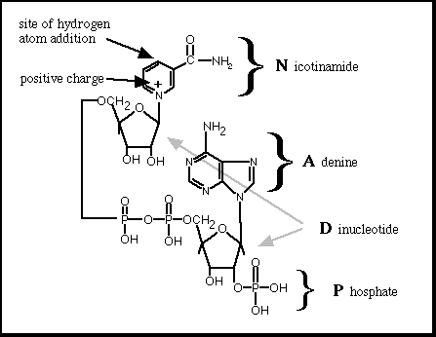
ATP is Adenosine Triphosphate
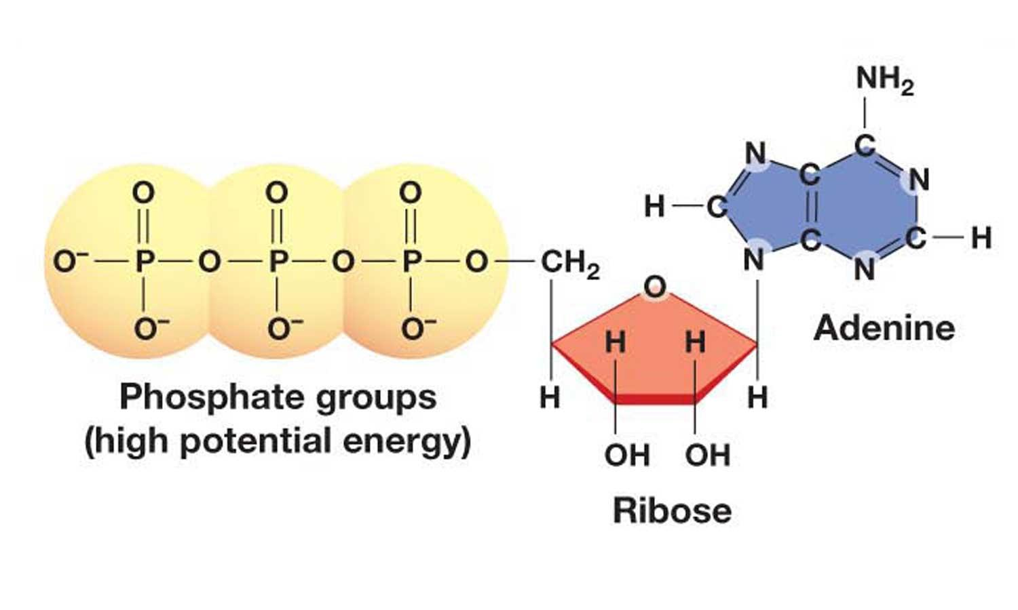
ATP stores energy for cellular work in the Phosphate bonds when a phosphate is bound to ADP (adenosine diphosphate)
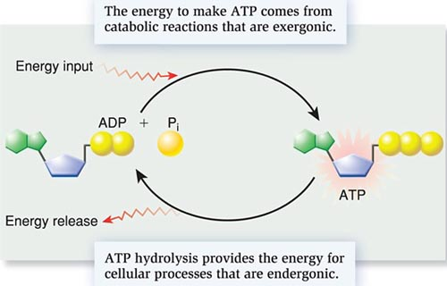
Steps of the Light Dependent Reaction
1) In the thylakoid space, water is split into hydrogen ions, electrons, and oxygen.
Oxygen diffuses out of the chloroplast and out of the leaf through the stomata
2) The photosystem gathers light energy and it energizes the electron
3) The electron passes through the electron transport chain and gives energy for the transmembranal proteins to pump hydrogen ions from the stroma into the thylakoid space
4) The electrons are reenergized at a second photosystem and then pass to NADP+ reductase where they join a hydrogen ion and NADP+ to make NADPH
5) The hydrogen ions that have been pumped into the thylakoid space have built a chemical gradient that pass through ATP Synthase (facilitated diffusion) to make ATP.
The ATP and NADPH are then used in the Light Independent Reaction

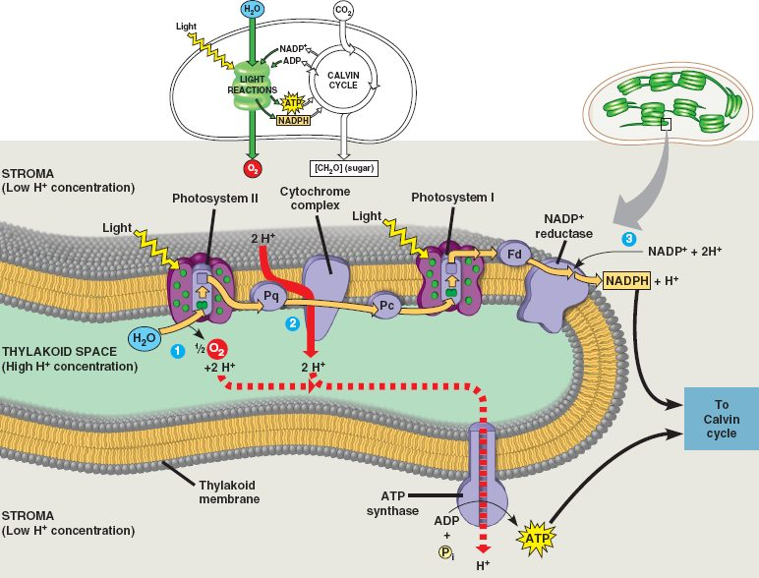

Light Independent Reaction
Occurs in the stroma of the chloroplast
Called the “Dark” reaction because it does not need light, but can occur in the light.
Also known as the Calvin Cycle
Requires:
Carbon Dioxide
Energy from ATP
Hydrogens and Electrons from NADPH
Rubisco: Carbon fixing enzyme
Process of Light Independent Reaction
Rubisco binds three carbon dioxide molecules together using the energy of ATP and adds hydrogens and electrons from NADPH.
This occurs twice forming two molecules with three carbons each. These are then joined to make glucose.

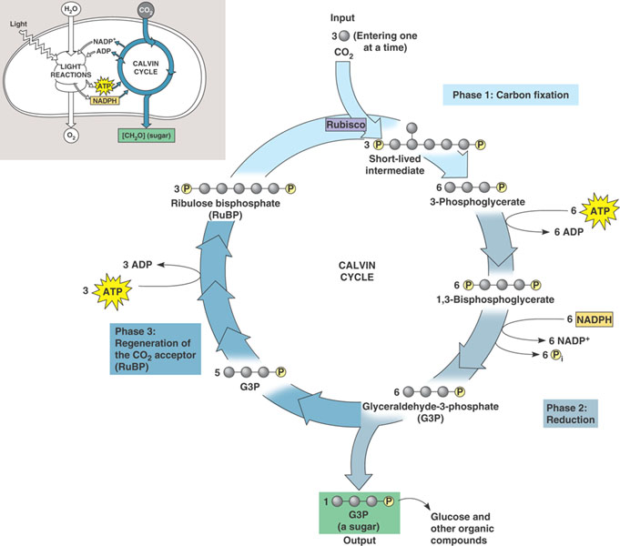

Summary:
6 H₂O + 6 CO₂ 6 O₂ + C₆H₁₂O₆
Dark Reaction
Stroma
Dark Reaction
Stroma
Light Reaction
Thylakoid
Light Reaction
Thylakoid

