Honors Biology Name: _____________________________
NDHS Per: __________ Date: ________________

Muscle Contraction
Basis of Muscle Contraction = Actin filaments (microfilaments) and Myosin Proteins
Muscle Structure:
Muscle is made of Fascicles.
Fascicles are made of clusters of muscle fibers (Muscle Cells)
Muscle fibers are made of Myofibrils
Myofibrils are made of sarcomeres
Sarcomeres are made of Actin and Myosin
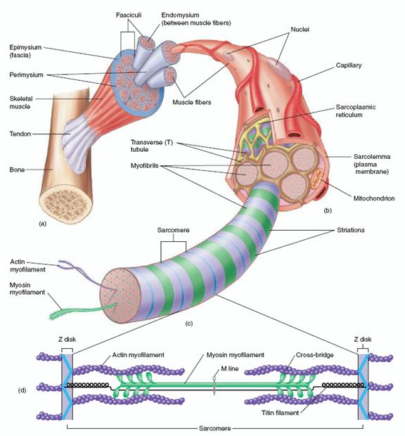

Almost every muscle is attaches to a bone at each end using tendons.
Exception: the tongue.
When muscles contract they pull on the tendons which pull on the bones causing the bones to move.

Muscle Contraction
Requirements:
Energy: ATP (Adensosine Triphosphate)
Calcium Ions – stored in the smooth E.R. of the Sarcomere – called the Sarcoplasmic Reticulum
Actin and Myosin
Process:
1) A signal is sent from the brain to the muscle by a motor neuron
2) The motor neuron releases a chemical called acetylcholine
3) Acetylcholine causes the Sarcoplasmic Reticulum to release Calcium Ions
4) Calcium Ions allow myosin to bind to actin and pull the actin filaments closer together
Myosin must first be activated by ATP.
ATP binds to Myosin making it ready to bind to the actin
When the mysosin binds to the actin, the ATP leaves and the myosin moves the actin forward
This repeats until the muscle is fully contracted.
Muscle Relaxation:
Calcium ions are pumped back into the Sarcoplasmic Reticulum
Myosin can’t bind to the actin anymore so the actin slides back into place.
This is added by Potassium (K+) Ions
Building Muscle
Exercise creates microtears in the muscle fibers = soreness
When the microtears are repaired the muscle cells get thicker = bigger muscles
Lactic Acid causes the “burning” in your muscles during and shortly after a workout but is gone within hours of the end of the workout.

