Honors Biology Name: ______________________________
NDHS Per: ___________ Date: ________________
Linked Genes and Human Inheritance
Humans have approximately genes that code for traits.
However, only have . Thus each chromosome must have on them.
If genes are on the same chromosome they are . These genes are called .
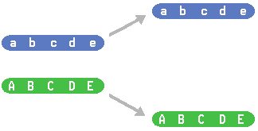
Often seen in :
Genes that are found on the .
Sex Chromosomes determine gender:
Mammals:
________________: the other chromosomes that are
AKA:
Types of Sex Linked Traits
______________: genes found on the
Can be passed from
Can be passed from
______________: genes found on the
Can be passed from
Since , they only need ______________________________ _______. This is called . (Hemi means half)
This is why X-linked recessive traits are .
Examples:
_________________ can only be passed to males.
Example: SRY gene – this is what makes boys
Example Problem:
John Smith is color blind. Melody is not. John and Melody have two daughters who are not color blind. Their first daughter, Martha, marries a man who is not color blind. Donna, their second daughter, marries a man who is color blind. What is the probability that John and Melody’s grandchildren will be color blind? Assume each couple has one boy and one girl.

Make a key and make a Punnet square for each cross.

The inheritance of the Smith family can be drawn as a .
Pedigree Charts use to show the relationships and inheritance of a particular trait, whether it be sex linked or autosomal. 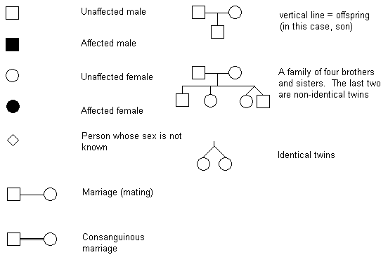
Pedigree Charts are labeled:
Each Line is given a Roman numeral and each individual on the line is given a number.
Draw a pedigree chart for the Smith Family:
Expression of X Chromosomes In Females:
Only chromosome is needed . In females, one of the X chromosomes is . The X chromosome and becomes known as a .
RESULT: As the female develops, it is a that determines which chromosome becomes the Barr Body. Therefore, if the female is heterozygous for a trait on the X chromosome, she can actually express .
Example: . Orange and black fur being expressed. One X is orange and the other is Black. Since the cells only express one of the X chromosomes, the fur will either be orange or black.
Implication: Only female cats can be calico.

Implications of Linkage for Dihybrid Crosses:
Because genes that are linked are inherited together, they do not independently sort when gametes are formed.
EX: Genes A and B are linked on the same chromosome. An individual is heterozygous for each gene.
A

B
a

b

Since the , there are only : .
If the genes were on , there would be :
_________________
b

B

a

A

Example Problem: The human traits for red hair and freckles are closely linked on chromosome 16. Red hair is a recessive trait while having freckles is a dominant trait. If a brown haired, freckled man (whose mother had red hair and no freckles and father had brown hair and freckles) marries a red headed, no freckled woman, what is the probability they will have red headed, freckled, children?

HOWEVER, because of , linked genes can ____________________. This results in chromosomes that are ________________________ _____________ and are called ______________ _____________________.

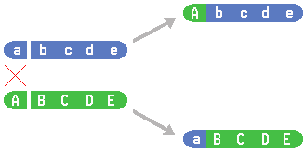

Recombination will only be seen if the individual is . If they are ___________________, the ___________________________________________________.
Heterozygous Cross
A

B
a

b
a

B
A

b

Homozygous Cross
A

B
A

B
A

B
A

B

IF crossing over does occur, it will only happen a certain percentage of the time. This is called the = __________________________
______________________________.
The are found on the chromosome they will cross over.
If two genes are known to cross over at a certain recombination frequency then the number offspring can be calculated based on the ____________________ __________________. The percentage of recombination _________________ _____________________________________.
Example 1: NO CROSSING OVER
A

B
a

b
All gametes formed are .
Example 2: Crossing over occurs .
A

B
a

b
80% of the time nothing happens and the gametes are .

A

B
a

b
a

B
A

b
20% of the time crossing over occurs and the
gametes are .

Therefore 40% of the gametes are
40% of the gametes are
10% of the gametes are
10% of the gametes are
Example 3: If two genes cross over 30% of the time, how often (percent) will each type of gamete form?
A

B
a

b

Using recombination frequencies in dihybrid crosses.
When two genes cross over with a certain recombination frequency, then a dihybrid cross is carried out using a heterozygous individual and a homozygous recessive individual.
The cross is done like a except the _________ ________________________________________________________________.
Example: In the purple crested blifflecooter, the purple crest gene is dominant over the green crested gene. The gene for rounded snouts is dominant over the pointed snout gene. Both of these genes (crest and snout) are on the same chromosome and cross over 20% of the time. If a male blifflecooter that is heterozygous for both traits is crossed with a green crested, pointy snouted female, how many of the 20 offspring can be expected to have purple crests and pointy snouts? (It is important to know that the male is descended from a pure bred purple crested, round snout and a pure bred green crested, pointy snout)

