Honors Biology Name: _____________________  
NDHS Per: ________ Date: __________  
  
**Honors Biology Spring Semester Exam Study Guide**

**Subjects:**Genetics, DNA Structure and Replication, Protein Synthesis, Evolution, Classification, Plants, Animals

**Approximate Break Down:**30% Genetics Problems  
50% DNA, Protein Synthesis, DNA Technology and Evolution  
20% Classification

**Contents**:  
**Genetics Terms and Concepts**: Complete (regular) Dominance, Incomplete Dominance, Co-dominance, Monohybrid cross, Dihybrid cross, Co-dominance, Incomplete dominance, Multiple Alleles, Human Blood Type, Epistasis, Linked Genes, Recombination and Cross Over, Sex Linked Traits, P generation, F1 generation, F2 generation, genes, alleles, homozygous, heterozygous, genotype, phenotype, test cross, parental type, recombinant

**Genetics Problems:**1) Lustrous fleece in sheep is dominant over recessive normal fleece. A ram with a lustrous fleece mates with a normal fleece ewe and they produce twin lambs with normal fleece. What are the genotypes of the parents?

2) In alien species called the zorkwipnups have been studied by scientists for many years. It has been found that the gene for four eyes is dominant to the gene for three eyes. Scientists have a four eyed female and a three eyed male which produce 19 four-eyed offspring and 32 three eyed offspring. What is the genotype of the female?

3) Zorkwipnups either have antenna or not. This is an X-linked dominant trait. A heterozygous female mates with a hemizygous male. How many of the offspring can be expected to have antenna?

4) Two black guinea pigs are mated. Some of the offspring are white. Explain.

5) Genes A and B are linked on the same chromosome. Two individuals AAbb and aaBB have an offspring. What is the chromosomal structure of the offspring? (how do the alleles look on the chromosomes? If these genes cross over 10% of the time, what types and percentages of gametes will be formed from the F1 generation?

6) woman who belongs to the blood group A and is Rh positive has a daughter who is O positive and a son who is B negative. Rh positive is dominant over Rh negative.

What is the possible genotype for the son?  
What is the possible genotype of the father?

7) Wolves are sometimes observed to have black coats and blue eyes. Assume that these traits are controlled by single [locus](http://www.ksu.edu/biology/pob/genetics/defin.htm#loc) genes and are located on different [chromosomes](http://www.ksu.edu/biology/pob/genetics/defin.htm#chrom). Assume further that normal coat color (N) is [dominant](http://www.ksu.edu/biology/pob/genetics/defin.htm#dom) to black (n) and brown eyes (B) are dominant to blue (b). Suppose the alpha male and alpha female of a pack (these are the dominant individuals who do most of the breeding) are black with blue eyes and normal colored with brown eyes, respectively. The female is also [heterozygous](http://www.ksu.edu/biology/pob/genetics/defin.htm#het) for both traits. How many of the offspring (assume 16) living in the pack will have each of the genotypes?

8) The lubber grasshopper is a very large grasshopper, and is black with red and yellow stripes. Assume that red stripes are expressed from the [homozygous](http://www.ksu.edu/biology/pob/genetics/defin.htm#hom) RR [genotype](http://www.ksu.edu/biology/pob/genetics/defin.htm#gen), yellow stripes from the homozygous rr genotype, and both from the [heterozygous](http://www.ksu.edu/biology/pob/genetics/defin.htm#het) genotype. What will be the [phenotypic ratio](http://www.ksu.edu/biology/pob/genetics/defin.htm#phent) of the [F1 generation](http://www.ksu.edu/biology/pob/genetics/defin.htm#f1) resulting from a cross of two grasshoppers, both with red and yellow stripes (red : both : yellow)?

9) A naturalist visiting an island in the middle of a large lake observes a species of small bird with three distinct types of beaks. Those with short, crushing beaks (BB) consume hard shelled nuts, those with long, delicate beaks (bb) pick the seeds from pine cones, and those with intermediate beaks (Bb), consume both types of seeds though they are not as good at either. Assume that this difference in beak morphology is the result of incomplete dominance in a single [locus](http://www.ksu.edu/biology/pob/genetics/defin.htm#loc) gene. What cross will have the best adapted offspring in a year in which most of the food available is in the form of hard shelled nuts?

10) Snow leopards live in the high reaches of the Himalayas and have several adaptations to deal with living most of the time in snow. They have wide paws with hair between the toes to allow them to run on top of the snow crust. Assume that wide paws (W) and hair between the toes (T) are both [dominant](http://www.ksu.edu/biology/pob/genetics/defin.htm#dom) traits and are on the same [chromosome](http://www.ksu.edu/biology/pob/genetics/defin.htm#chrom) that do not cross over. Suppose that two snow leopards, [heterozygous](http://www.ksu.edu/biology/pob/genetics/defin.htm#het) for both traits, mate. Suppose further that in the female, the two dominant [alleles](http://www.ksu.edu/biology/pob/genetics/defin.htm#dom) are on the same chromosome of the [homologous](http://www.ksu.edu/biology/pob/genetics/defin.htm#homl) pair, while in the male, each chromosome of the pair has one dominant and one [recessive](http://www.ksu.edu/biology/pob/genetics/defin.htm#red) allele. What is the genotypic and phenotypic ratio?

11) The skin pattern of the green lily pad frogs can be solid green, striped, or spotted. This characteristic is controlled by one gene pair with three allelic possibilities. In this case green is dominant over spotted, and spotted is dominant over striped.

A green male mates with a striped female to produce, green and spotted offspring. Show the cross that demonstrates the males genotype.

12) The darkness of the skin pattern of the green lily pad frogs is controlled by two gene pairs which have two allelic possibilities, dark green and pale green. The greater the amount of dark green genes results in darker green skin. If two medium green frogs mate, what is the probability they will have a very pale green offspring?

13) Four genes: A, B, C, and D are all on separate chromosomes.

Two Individuals AABbCcdd an AaBbccDd are crossed.

What is the probability for the following offspring?

1. AaBBccdd
2. AABBCcDd
3. AABBCCDD

14) The following is a pedigree chart for an autosomal dominant disease.

What are the genotypes for the following individuals?

1. I-1 b) II-3 c) III-2

**DNA Structure:**Draw the basic structure of DNA  
- phosphate sugar backbone  
- nitrogenous base pairs  
- anti-parallel

**DNA Replication:**Enzymes and Proteins: Topoisomerase, Helicase, Single Strand Binding Proteins, RNA Primase, DNA polymerase, Ligase   
Important Ideas:  
- impact of 5’ and 3’  
- Leading and Lagging Strands  
- Semi-conservative

Draw it out and label.

**Protein Synthesis:**Transcription: Enzymes and Process  
 What are the enzymes involved in transcription? What do each of them do?

RNA Modification: Where, What and How  
 What are the three main things that happen in RNA modification?

Translation: Where, What and How  
 Explain what is happening in translation?

Transcribe and Translate a sequence of DNA to RNA and then to Protein using mRNA Codon Chart

DNA: 3’ TAG CGG GAT CAC ATT 5’  
 mRNA:  
Amino Acid:

Point Mutations:  
 What is a point mutation? Do these always have a negative impact? Why or why not?

Insertions and Deletions: Frame Shift Mutation –explain how these changes in DNA change the resulting mRNA and protein

**DNA Technology:**Restriction Enzymes  
 What are restriction enzymes? Where do they come from? How are they used in DNA technology? How do they cut DNA? How can they be used to make a cloning vector?

Genetically modified organisms: Pros and Cons

Polymerase Chain Reaction  
 How does the polymerase chain reaction work to make new copies of DNA? How are the products of PCR used in DNA technology?

DNA Electrophoresis:  
 Explain the process of DNA electrophoresis and HOW the DNA pieces move and are separated in the process. How is this information used?

**Evolution**:   
TERMS: Fitness, Natural Selection, Speciation, Directional Selection, Disruptive Selection, Stabilizing Selection, Genetic Drift, Bottleneck Effect, Founder Effect, Homologous Structures, Analogous Structures, Molecular Homologies

Points and Causes of Natural Selection

Evidences of Evolution

**Classification**:  
Construct and Explain a Cladogram.  
- complete the chart with a “+” for has the trait and a “–“ for not possessing the trait.  
- draw a Ven diagram with the least specific organism on the outside and the most specific on the inside  
- draw the cladogram with each change being a new clade (branch)

|  |  |  |  |  |  |  |
| --- | --- | --- | --- | --- | --- | --- |
| Organism | Nucleus | Multicellular | Specialized  Tissues | Cartilagenous  Skeleton | Bony  Skeleton | Protected Egg |
| Bacteria |  |  |  |  |  |  |
| Amoeba |  |  |  |  |  |  |
| Sponge |  |  |  |  |  |  |
| Jellyfish |  |  |  |  |  |  |
| Shark |  |  |  |  |  |  |
| Frog |  |  |  |  |  |  |
| Lizard |  |  |  |  |  |  |

**Plants:** - Groups and Characteristics: Make a chart

Groups: Bryophytes, Ferns, Gymnosperms, Angiosperms  
Characteristics: Vascular Tissue, Spores, Seeds (Naked or Covered), Cones, Flowers

Monocot Characteristics vs Eudicot characteristics.

- Reproductive Differences: You **do not** need to know the details of how each type of plant reproduces just which groups have the following characteristics:- motile sperm, spores vs seeds, naked seeds, covered seeds, flowers and cones and fruits - Monocots vs Eudicots

Label A Typical Flower: Stamen (anther, filament, pollen), Pistil (stigma, style, ovary), Petal, sepal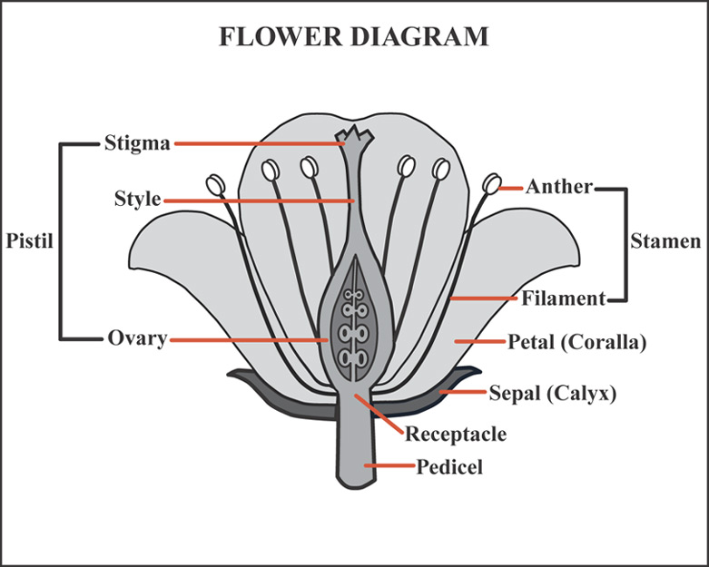

Why are seeds better than spores for survival?

**Animals:**Groups and Characteristics – you will need to know which groups have/do not have the following characteristics: radial symmetry, bilateral symmetry, gastrovascular cavity, complete digestive system, gills, lungs, exoskeletons, internal skeletons (bone or cartilage), protected eggs (leathery or hard shell), 2,3, or 4 chambered hearts, endotherm or exotherm, hair, nurse young ( I HIGHLY SUGGEST LOOKING AT THE REVIEW POWERPOINT ON LINE)

**ANSWER KEY to Study Guide Problems**

1. Ll X ll – in order to get the recessive trait the ram must be heterozygous
2. Heterozygous
3. 75% will have antenna. All the females will as well as half the males.
4. They are heterozygous.
5. Ab = 45%, aB = 45%, AB = 5%, ab = 5%
6. Son = IBi rr; Father = IBi __ r
7. Give the ratios = 4:4:4:4 or 25% each or 4 each
8. 1:2:1
9. BB x BB
10. Give Ratios:   
    WwTT:WWTt:wwTt:Wwtt  
    25 % of each
11. Male’s genotype is Green/Spotted
12. 1/16
13. a) 1/32 b) 1/32 c) 0
14. a) Dd b) Dd c) dd

Classification:

|  |  |  |  |  |  |  |
| --- | --- | --- | --- | --- | --- | --- |
| Organism | Nucleus | Multicellular | Specialized  Tissues | Cartilagenous  Skeleton | Bony  Skeleton | Protected Egg |
| Bacteria | - | - | - | - | - | - |
| Amoeba | + | - | - | - | - | - |
| Sponge | + | + | - | - | - | - |
| Jellyfish | + | + | + | - | - | - |
| Shark | + | + | + | + | - | - |
| Frog | + | + | + | - | + | - |
| Lizard | + | + | + | - | + | + |

Amoeba

Liz

Bac Am Sp Jell Sh Fr

Bacteria

Lizard

Frog

Shark

Jellyfish

Sponge