Honors Biology Name: __________________
NDHS Per: ______ Date: ________
Genetics Test Study Guide

Patterns of Inheritance
Complete (regular) Dominance, Incomplete Dominance, Co-dominance, Multiple Alleles, Polygenic Inheritance, Environmental Influence on Phenotype

Genetics Problems:
Monohybrid cross
Dihybrid cross
Co-dominance
Incomplete dominance
Multiple Alleles
Human Blood Type
Epistasis
Polygenic traits
Linked Genes
Recombination and Cross Over
Sex Linked Traits
Pedigree Analysis

Vocabulary:
P generation, F1 generation, F2 generation, monohybrid, dihybrid, pure bred, hybrid, Law of Dominance, Law of Segregation, Law of Independent Assortment, genes, alleles, homozygous, heterozygous, hemizygous, genotype, phenotype, test cross, X-inactivation (Barr Bodies), parental type, recombinant

1) An alien species, which we will call Nulops, has been studied for the last decade by scientists. The Nulops are known for their two basic scale colors (green and pink) and their wings (bat like wings or butterfly like wings). From the intense genetic research, the resulting information was discovered about their inheritance patterns. Green scales are dominant over pink scales and butterfly wings are dominant over bat-like wings.

What would be the genotypic and phenotypic ratios of a mono-hybrid cross for scale color of a Heterozygous male and a Homozygous dominant female?

2) What would be the genotypic and phenotypic ratios for the following di-hybrid cross?
A male with a homozygous recessive scale color and a heterozygous wing type
A female with a heterozygous scale color and a homozygous recessive wing type

- Assuming Complete Dominance, what are the genotypes of the parents if the following genotypic and phenotypic ratios are obtained assuming the parents?
G: 4:0, P: 4:0 (3 Possibilies)
G: 1:2:1, P: 3:1
G: 2:2, P: 2:2
4) Genes A and B are cross over 12% of the time. A heterozygous individual, whose parents were AAbb and aaBB, would be expected to produce gametes in the what frequencies?

5) Gruzdelicans have two types of beaks, the dominant pointed beak and the recessive curved beak. They also have two types of calls, the dominant “Whoop-Whoop” and the recessive “Wah-Wah”. If a curved beak, wah-wah mates with a heterozygous pointed beak, homozygous whoop-whoop, what percentage of the offspring will be curved beak, whoop-whoopers?

6) Snorkshooshanks have large heads (dominant) or small heads (recessive) and purple toes (dominant) or orange toes (recessive). These genes are on separate chromosomes. A cross between a male who is who shows the dominant trait for each characteristictrait and a female who is homozygous recessive for both traits results in the production of the following offspring.
Large Head, Purple Toes: 16 Large Head, Orange Toes: 14
What is the genotype of the father?

7. In pea plants purple flowers are dominant over white flowers and tall plants over short plants. If a homozygous purple flowered short plant is crossed with a white flowered, homozygous tall plant, what will the genotypes of the offspring be?

8) Bimbleflicks have either long, medium, or short arms due to incomplete dominance. If two medium arms bimbleflicks have little bimbleflickers, what is the genotypic and phenotypic ratio?

9) Black fur in labs is dominant over brown. However, another gene, if homozygous recessive, makes the dog yellow. If a yellow lab, whose parents were purebred for brown fur, mates with another dog who is heterozygous for both traits, how many will be black, brown, and yellow if 8 pups are born?

10) In rabbits, an allelic series helps to determine coat color: Full color is dominant over chinchilla which is dominant over Himalayan which is dominant over albino.

A full colored rabbit mates with a Himalayan to produce 6 full colored babies 3 Himalayan babies and 2 albino babies. Determine the genotypes of the parents.

11) Phenylketonuria (PKU) is a disease that results from a recessive gene. Two normal parents produce a child with PKU. What is the likely hood that their second child would also have PKU?

12) In cats, curled ears result from an allele that is dominant over an allele for normal ears. Black color results from an independently assorting allele that is dominant over an allele for gray color. A gray cat that is homozygous for curled ears is mated with a pure bred black cat with normal ears. All the F1 generation have black coats with curled ears. If two of the F1 generation mate, what is the expected phenotypic ratio of the F2?

13) One fish, two fish, red fish, blue fish. These fish mate and the young guppies have red and blue scales. Two of these guppies mate producing 20 new fish. How many will be expected to have blue scales?

14) A man with type A blood has a father who has type O blood. The man and his wife have a baby. If the woman is type B and her mother was type O, what are the possible blood types of the baby?

15) Maple syrup urine disease is a rare inborn error of metabolism that causes the urine to smell like syrup. Parents of affected individuals do not have the trait. What type of inheritance is this? Show a genetic cross that supports your analysis.

16)In cucumbers, dull fruit is dominant over glossy fruit, orange fruit is dominant over cream fruit and bitter seeds are dominant over non-bitter seeds. The three genes are on different chromosomes. Two plants that are heterozygous for all three traits are crossed. What is the probability of getting the following:
a) glossy fruit and orange fruit
b) dull fruit and non-bitter seeds
c) dull fruit and orange fruit
d) cream fruit and non-bitter seeds
e) glossy fruit, cream fruit, non-bitter seeds

17) A man who is color blind marries a woman whose father was color blind, but she is not. What is the likely hood that they will have a
a) child with normal vision
b) child with color blindness
c) a son with color blindness
d) a daughter with normal vision

18) Name the inheritance type:

a) Blue X Yellow = Green
b) Red X White = Red and White Spots
c) Tan X Tan = Dark Brown, Med Brown, Tan, Light Tan, Pasty White
d) Blue X Red = Blue, Red and White
e) Red X Red = 3 red and two white

19) The following pedigree chart traces the path of an autosomal dominant trait.
What are the genotypes of the following individuals?
a) II-5
b) II-4
c) III-1
d) IV-3

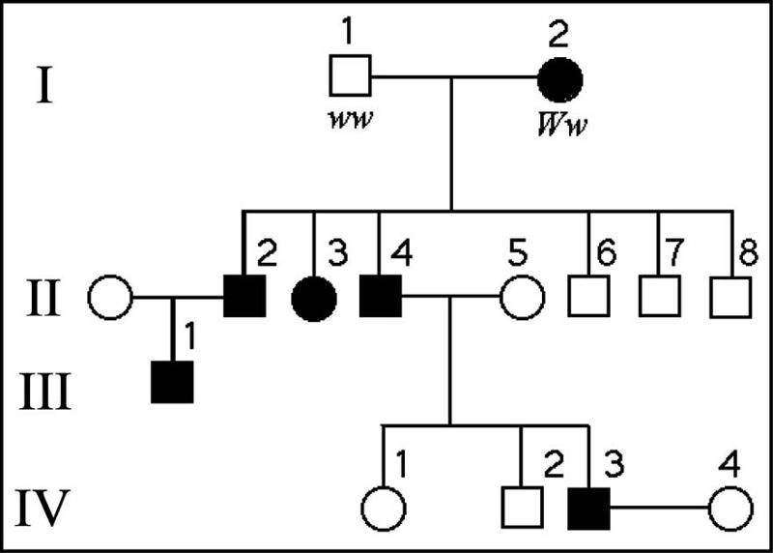

20) The following pedigree chart traces the path of an autosomal recessive trait. What are the genotypes of the following individuals?
a) I-1
b) II-4
c) III-2

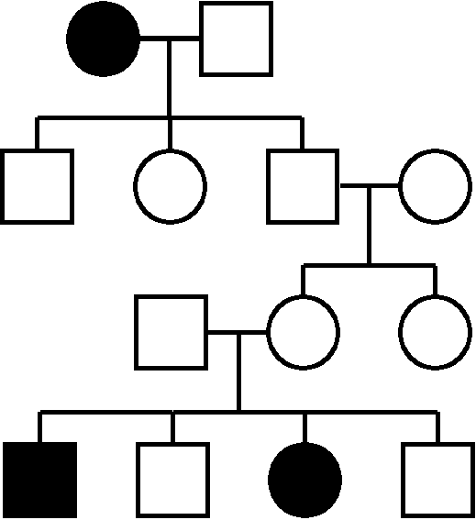

ANSWER KEY
- GgXGG = Geno: 2:2, Pheno 4:0
- Geno: 4:4:4:4, Pheno: 4:4:4:4
- Key: D = dominant, d = recessive
a) DDxDD, DDxdd, ddxdd
b) DdxDd
c) Ddxdd
4) 44% Ab, 44% aB, 6% AB, 6% ab
5) 50%
6) Mostl Likely LLPp
7) PpTt
8) Geno: 1:2:1, Pheno: 1:2:1
9) 2 Black, 2 brown, 4 Yellow
10) C^{F}c x C^{H}c
11) 25%
12) 9:3:3:1
13) 5 blue
14) A, AB, B, O
15) Complete (Regular) Dominance – trait is recessive and shows up from two carriers (heterozygotes)
16) a) 3/16
b) 3/16
c) 9/16
d) 1/16
e) 1/64
17) a) 50%
b) 50%
c) 25%
d) 25%
18) a) Incomplete Dominance
b) Co-Dominance
c) Polygenic Inheritance
d) Multiple Alleles
e) Regular Dominance
19) Key: D = dominant, d = recessive
a) ww
b) Ww
c) Ww
d)Ww
20) Key: D = dominant, d = recessive
a) dd
b) D_
c) Dd

