Honors Biology Name: ____________________
NDHS Per: ________ Date: _________
Gene Linkage and Sex-Linked Inheritance
A man who is color blind marries a normal visioned woman whose father was color blind, but mother was not.

What is the probability they will have a color blind child?

What is the probability they will have a color blind son?

What is the probability they will have a color blind daughter?

If a color blind female has a son with a color blind man, what is the probability he will be color blind?

Complete the genotypes for all of the individuals in the pedigree charts.
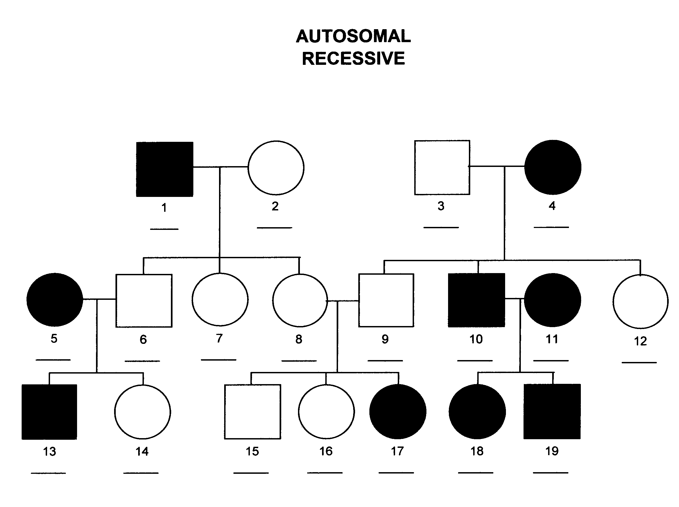
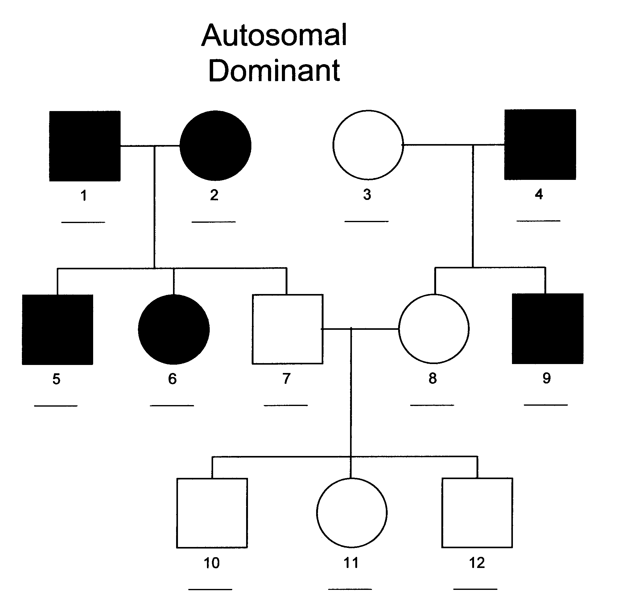

The genes for fur color and wing type are linked on the same chromosome in hattinpoots. Orange fur is dominant over blue fur. Feather wings is dominant over leather wings. A pure bred orange, feather winged male mates with a pure bred blue leather winged female resulting in an orange, feather winged hattinpootette (a baby hattinpoot). If this offspring breeds with a blue, leather winged individual, what is the probability a blue, feather winged offspring will be produced?

