Honors Biology Name: __________________________
NDHS Per: ________ Date: ______________
EVOLUTION
Basic Definition:
Biological Definition: change in the over time
- -
- changes in the population and eventually lead to
_____________________________________________________________
TYPES of Evolution
: change in the gene pool (genetic content) of a population based on natural selection
EX: normal variations
: change on a large scale leading to new and different species
Early Theories Influencing Darwin:
: seen in geology
- geologist - - geological systems are constant
: individuals acquired traits would be passed down to the next generation -
EX: giraffe and black smiths
ALL INFLUENCED DARWIN
-
- noticed similarities to other species on other islands and South American species
- CONCLUSION:
Darwin’s Finches:
- big beaks and little beaks
- plants make big seeds in dry season and little seeds in wet seasons
______________________________________________________________
-
Fitness vs Survival
- Survival =
- Fitness =
Viable =
POINTS of Natural Selection
1.
2.
3.
Results:
1.
2.
3.

EVIDENCE OF EVOLUTION:
- _____________: evidence of past species that are similar to current species
Age of Fossils Determined By Radiometric Dating:
- measuring the amount of in a sample and working based on how quickly those radioactive atoms decay into different atoms
- Known as the of a sample:
Ex: Carbon-14 has a half life of – this means if you have a 10 gram sample of C-14, it will take 5730 years for half of it (5 grams) to break down into Nitrogen 14 and another 5730 years to degrade to 2.5 grams and another 5730 years to degrade to 1.25 grams, etc.

Based on the ratio of C-14 and C-12 in the sample, the age can be determined.
For really old samples, other radiometric dating like potassium and uranium
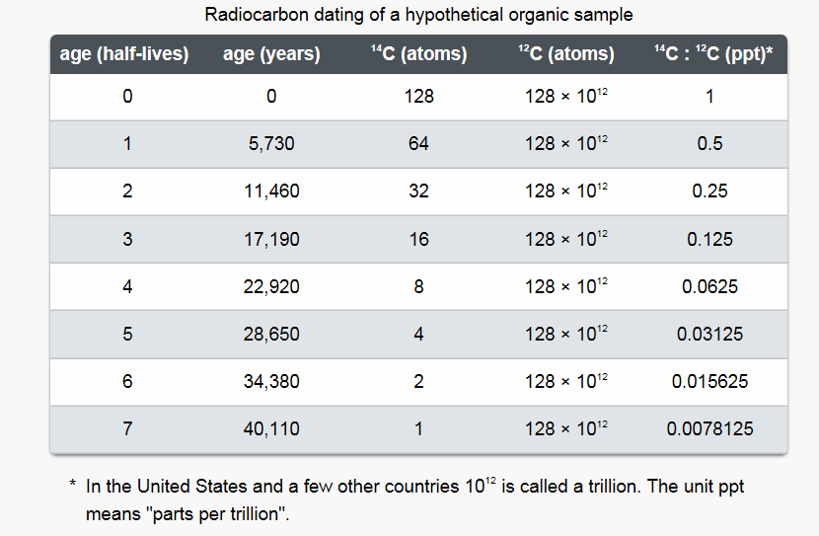
Problems:

2. _________________________
- species of and then change according to the
EX: South American species are going to be more like North American than Australian

3. :
-species that evolved from a
:
- from a common ancestor into different forms by different selective pressures (environmental conditions)
EX:
If the structure becomes unhelpful in terms of fitness, it may become a Vestigial Organ
:
- Different components but same function – shaped by similar environmental conditions

EX:

4. :
“ ”
ontogeny = phylogeny =
- means as the individual develops embryologically, the embryo shows the past history or evolution of the species
- ______________
Current Understanding: organisms with a common ancestor will show _________ ________ but will not express the traits of that past ancestor
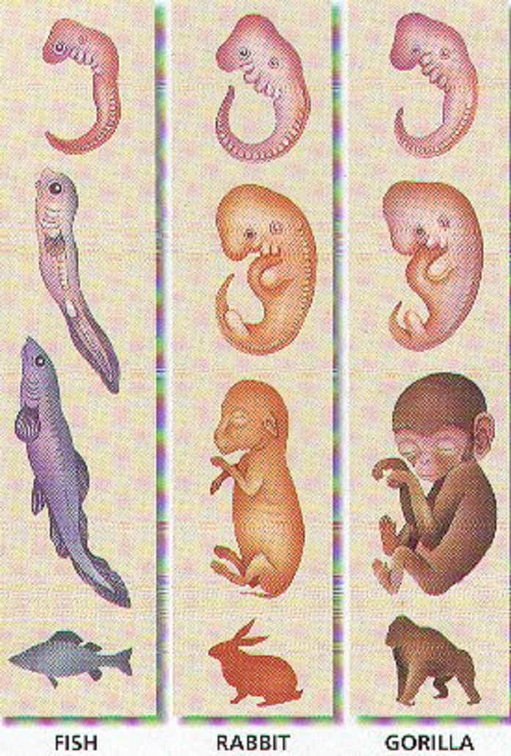
5.
Current Powerhouse of Evolutionary Research:
- look at DNA and Proteins to see how similar they are. The more they have in common, the more closely they are related.
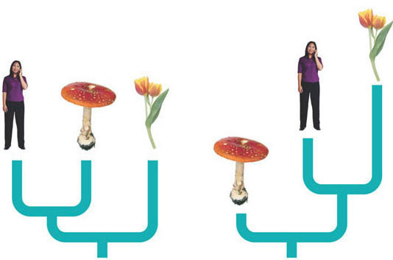
EX: Animals, Mushrooms and Plants

Causes of Microevolution
1.
- change in the gene pool due
-
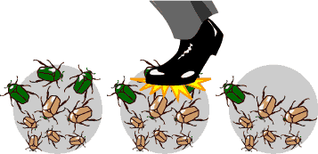
TYPES:

-
- become parents of resulting population
- can wipe out a certain trait
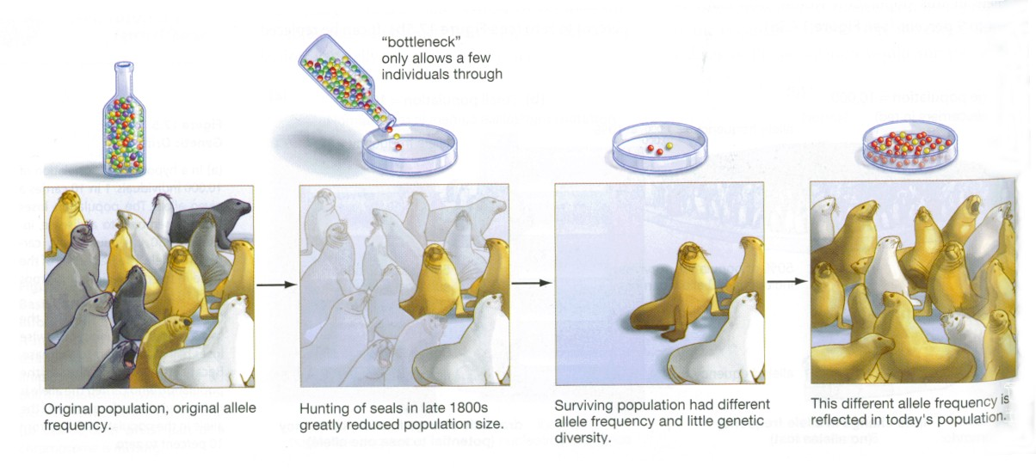

_____________________
- a few individuals start the population
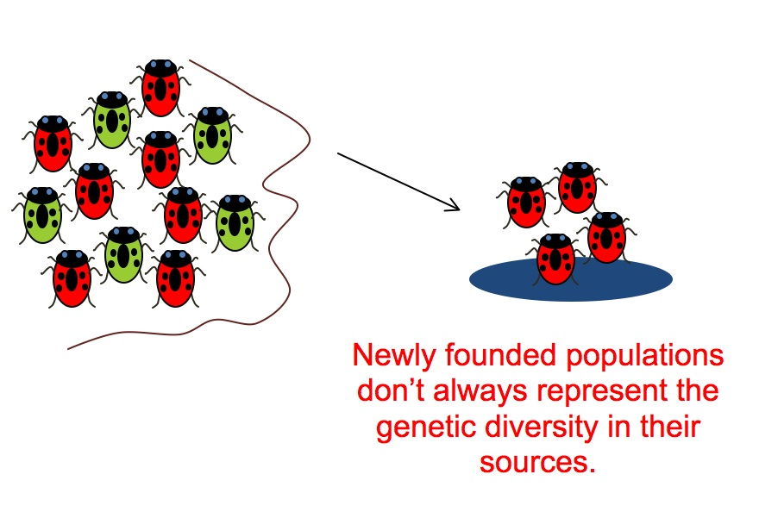
2.
- individuals introducing or removing new alleles
-
3.
- introduce
-

4.
- based on some characteristic
-
- isolates favorable traits
-
5.
- Selection Pressure by the Environment
-
-
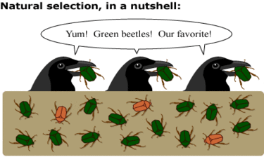
TYPES OF NATURAL SELECTION
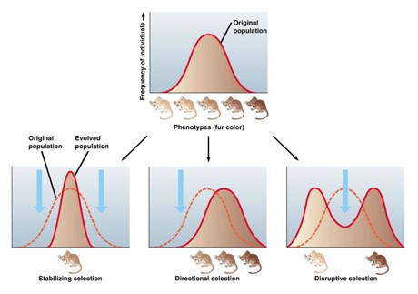
_____________________________: favors middle ground
- bird beaks, human birth weight
_____________________________:: favors and extreme
- giraffe
_____________________________:: does not favor middle ground - makes both extremes more frequent
- crabs that are black or white
GENETIC CHANGE CAN LEAD TO SPECIATION
- different environments = natural selection = speciation
HOW MUCH CHANGE IS ENOUGH?
various - depends on what is changed
TEMPO OF CHANGE: how fast
___________________________________
________________ = very small changes over a period of time
- not supported by fossil record
FOSSIL RECORD:
- shows -
- then disappear - replaced by something different
- little to no transition
POSSIBLE EXPLANATION: because they were in the soft tissues or were behavioral
- alternate theory:
-
- does not allow enough time for fossils to be formed so there are none

PREBIOTIC EVOLUTION:
IDEAS and SPECULATION of the ORIGIN of LIFE
Formation of the earth
THE YOUNG EARTH
- little atmospheric oxygen
- high UV
- lightning
- volcanos
- conducive to chemical reactions
- energy
- no oxygen to oxidize products and break them down
Hot mixture of chemicals
- formed amino acids and nucleic acids
- formed proteins and DNA
- formed simple cells (Protobionts)
- formation of heredity
- cells became more complicated
Evidence
Miller/Urey Experiment
- methane, water, ammonia, H2, and electricity
- excluded, CO, CO₂, N₂ and O₂
FOUND: produced amino acids and nucleotides and ATP

