Honors Biology Name: ______________________
NDHS Per: ____ Date: ______________

Evolution Discussion Questions
Discussion Questions:
- Explain why the population of mice changes the way it does
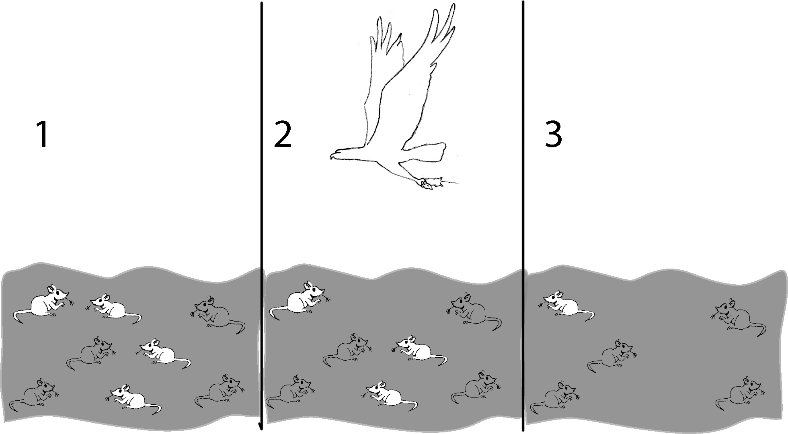

Living things that are well adapted to their environment survive and reproduce. Those that are not well adapted don’t survive and reproduce. An adaptation is any characteristic that increases fitness, which is defined as the ability to survive and reproduce.
- What characteristic of the mice in figure 1 was an adaptation that increased fitness?

The table describes four female mice that live in a beach area which is mostly tan sand with scattered plants.
Characteristics of each female mouse | Color of Fur
 | Black | Tan | Tan and Black | Cream
Running speed | 8 cm/sec. | 6 c/sec. | 7 cm/sec. | 5 cm/sec.
# pups produced by each female | 0 | 11 | 3 | 0
Age at death | 2 months | 8 months | 4 months | 2 months

- According to the definition given for fitness, which mouse would biologists consider the fittest? Explain why this mouse would be the fittest.

- If a mouse's fur color is generally similar to its mother’s color, what color fur would be the most common among the pups (baby mice)?
A heritable characteristic is influenced by genes and passed from parents to offspring. In the mice on the tan sand, tan fur was a heritable adaptive characteristic, and you saw how this characteristic became more common in the pups than in the mothers. In nature, heritable adaptive characteristics become more common in a population over many generations. This process is called evolution by natural selection.
Evolution by natural selection leads to adaptation within a population. The term evolution by natural selection does not refer to individuals changing, only to changes in the frequency of adaptive characteristics in the population as a whole. For example, for the mice that lived on tan sand, none of the mice had a change in the color of their fur; rather, due to natural selection, tan fur was more common for the pups than for the mother mice.
In summary, a heritable characteristic that helps an animal or plant to have more offspring which survive to reproduce will tend to become more common in a population as a result of evolution by natural selection.
- Explain why a heritable characteristic which helps an animal to live longer will generally tend to become more common in the population as a result of evolution by natural selection.

- Suppose a different heritable characteristic helped animals to live longer but made them sterile so they could not have any offspring. Explain why this heritable characteristic would not become more common as a result of evolution by natural selection.

The following example will illustrate that evolution by natural selection cannot occur if the variation in a characteristic is not heritable. This example also illustrates a more complete definition of fitness, which is the ability to survive and produce offspring who can also survive and reproduce. According to this definition of fitness, which of the four male lions described below would biologists consider the “fittest”?

Name | George | Dwayne | Spot | Tyrone
Age at death | 13 years | 16 years | 12 years | 10 years
# cubs fathered | 19 | 25 | 20 | 20
# cubs surviving to adulthood | 15 | 14 | 14 | 19
Size | 10 feet | 8.5 feet | 9 feet | 9 feet
(Adapted from Michigan State University, Occasional Paper No. 91, Evolution by Natural Selection: A Teaching Module by Beth Bishop and Charles Anderson, 1986)

Explain why Dwayne was not the fittest even though he lived the longest and fathered the most cubs.

7. Below is a series of pictures representing changes in a population of cacti. Pictures 1 and 2 show what happened when a deer came to eat, picture 3 shows the cacti a few weeks later (notice the flowers on the right-hand cactus), and picture 4 shows the situation a few months later.
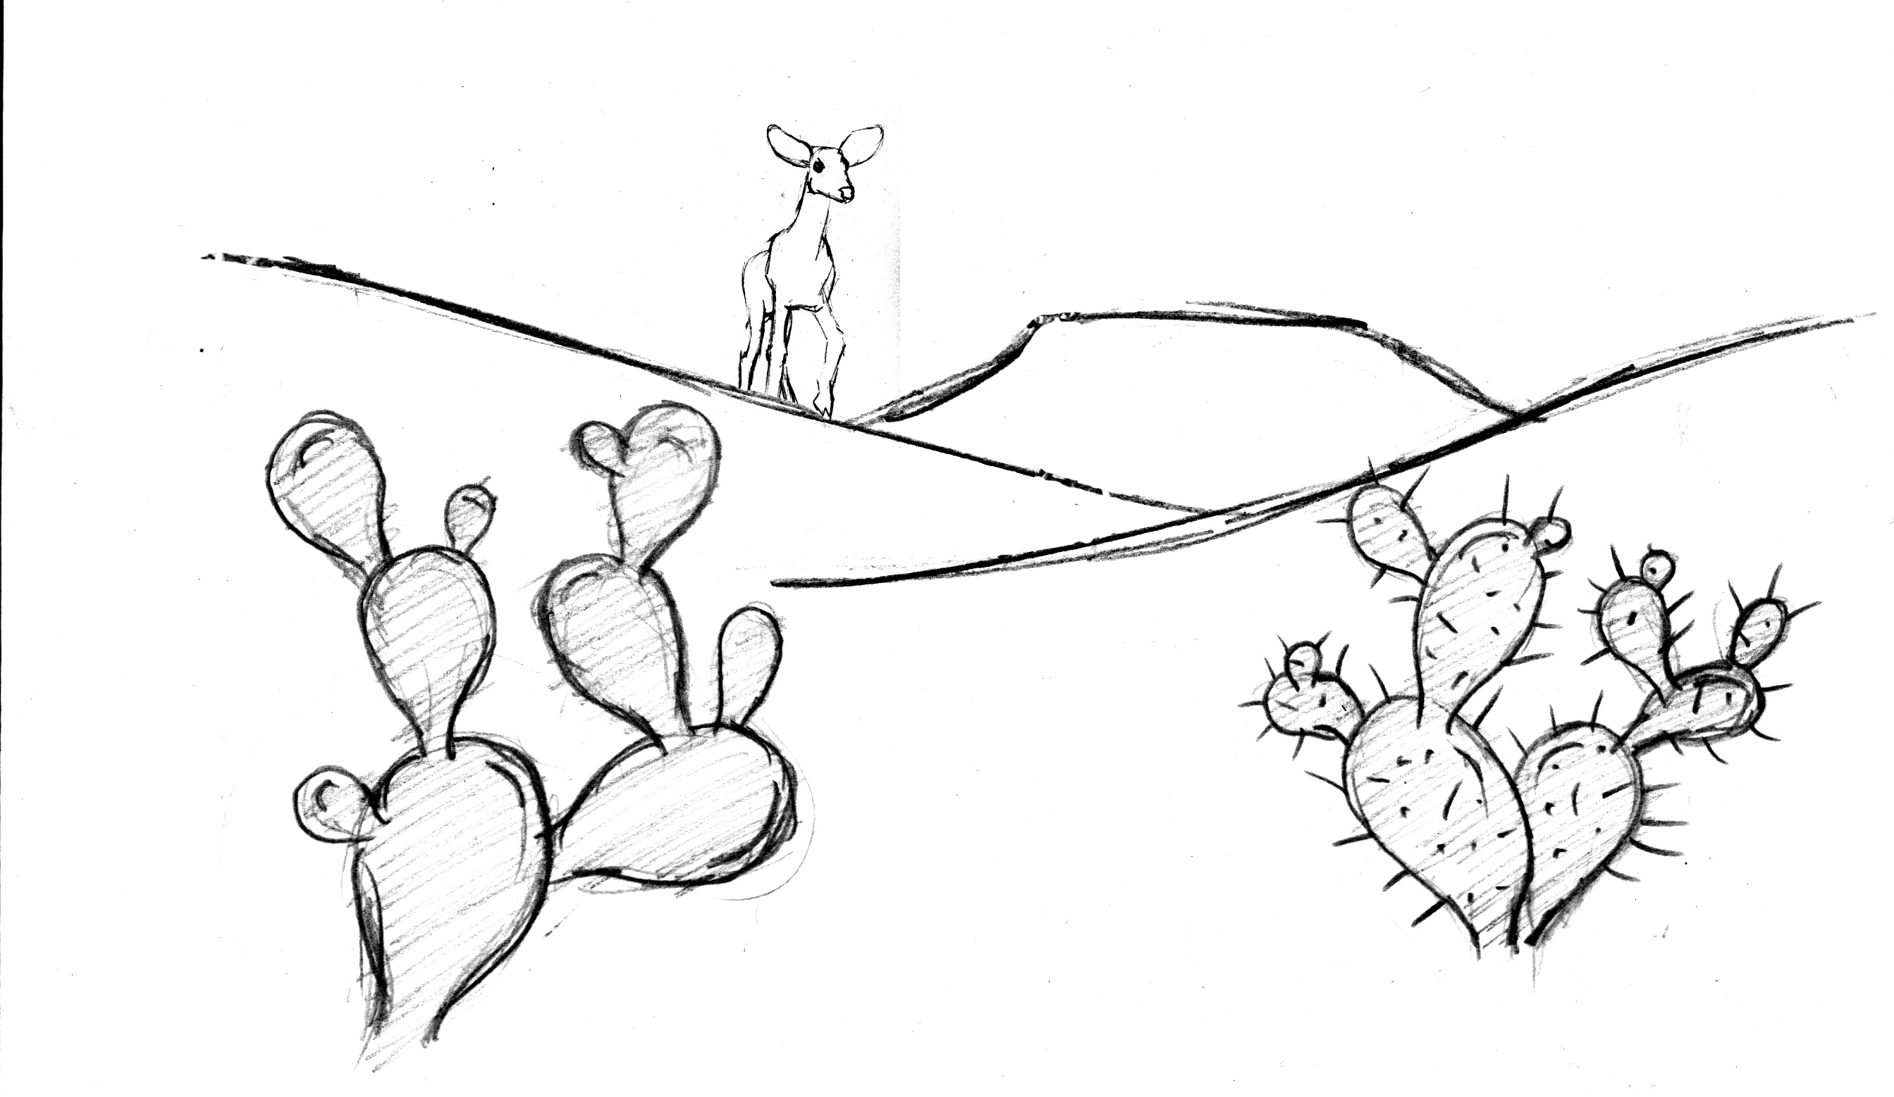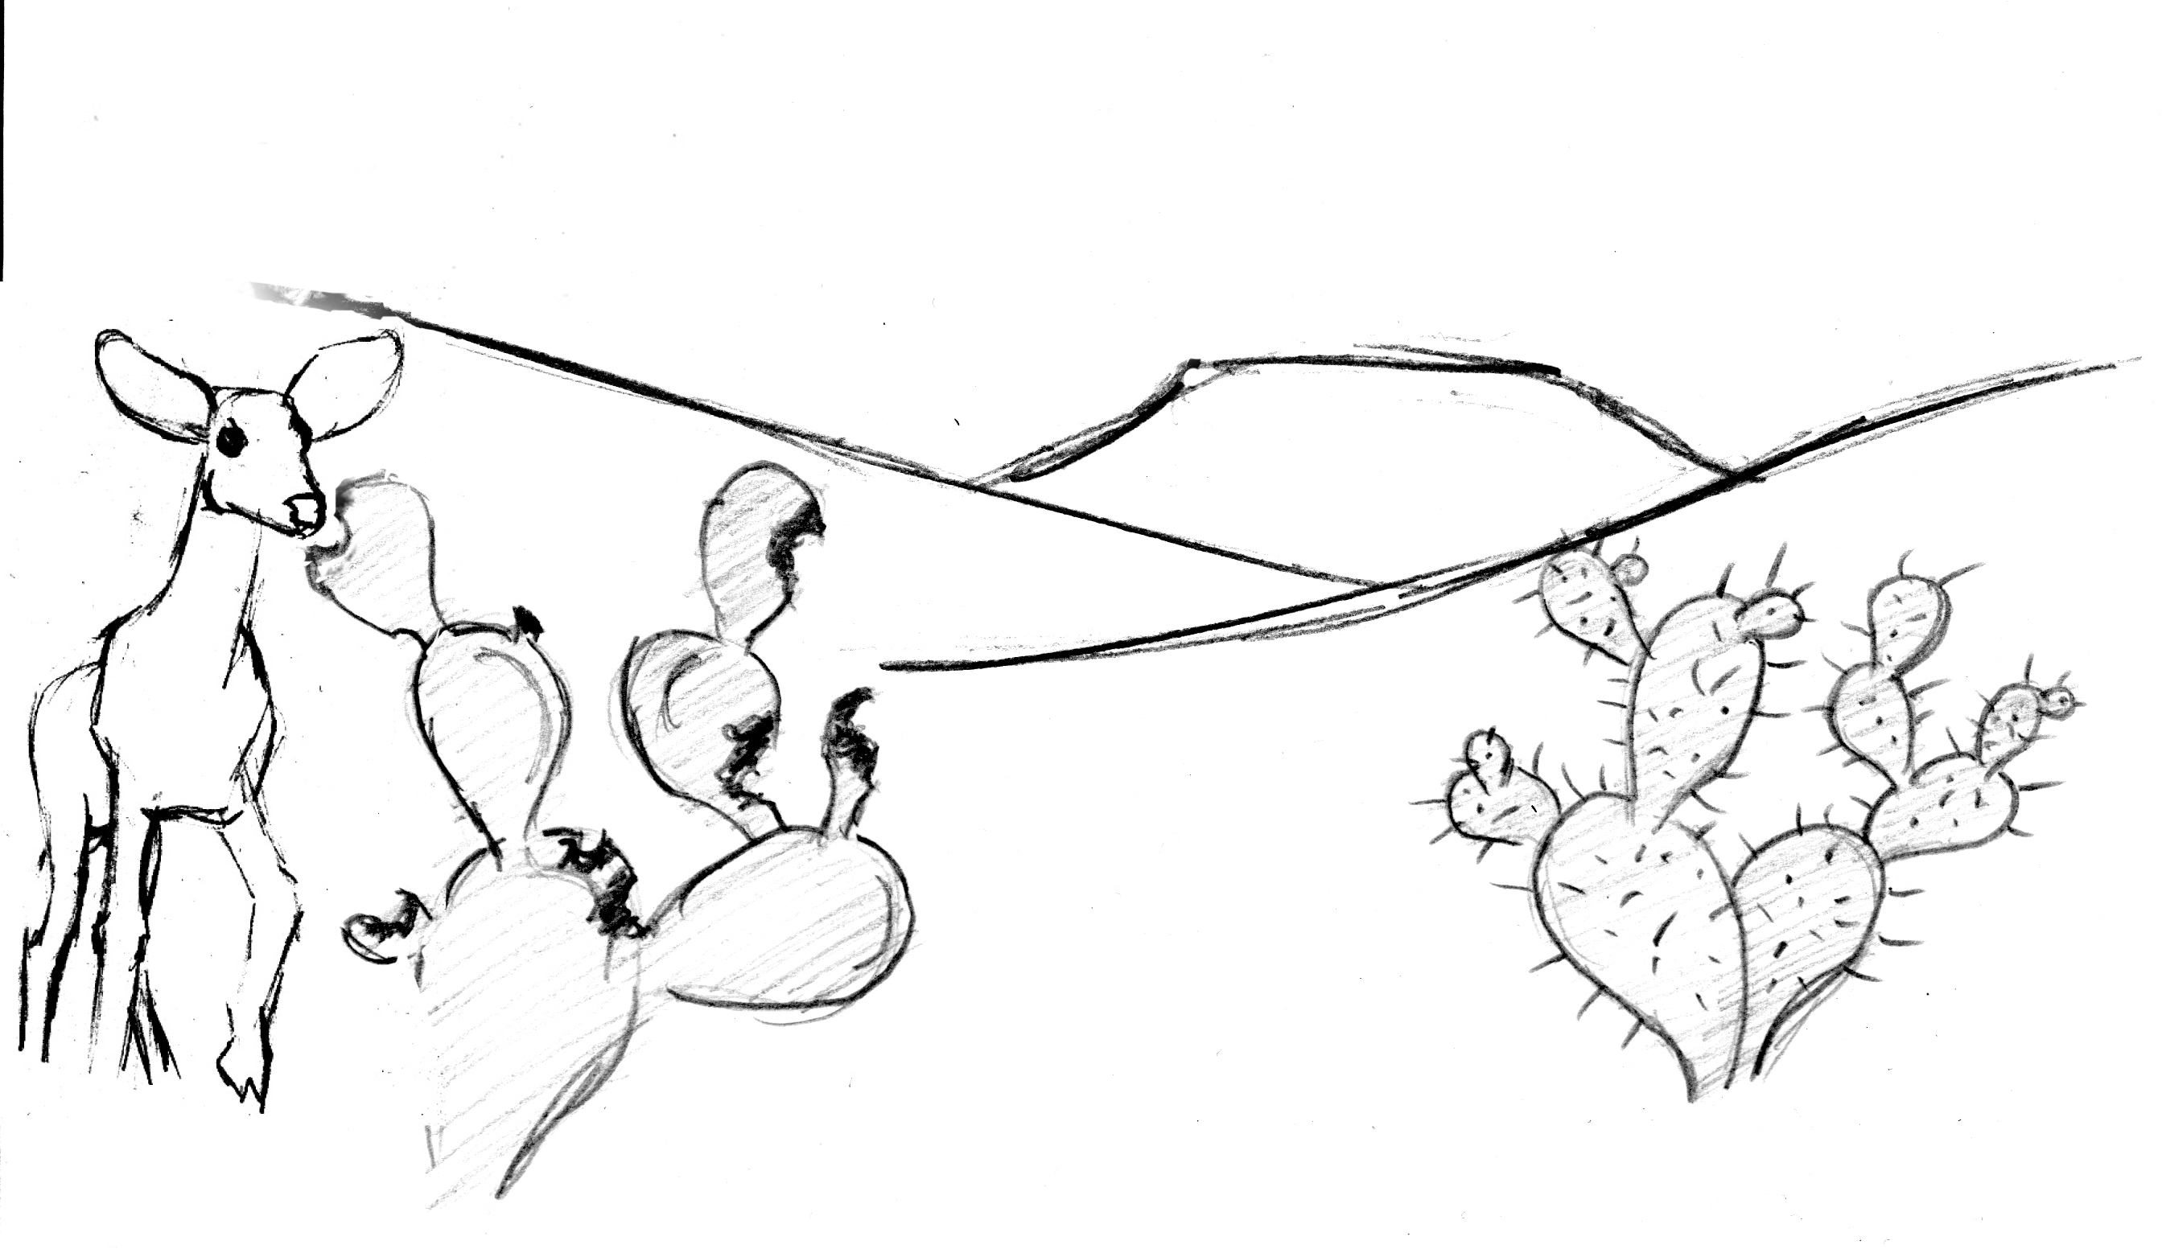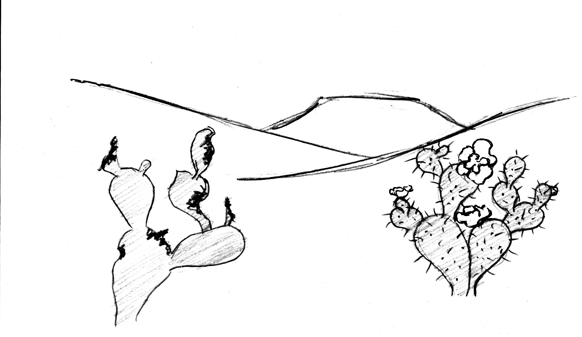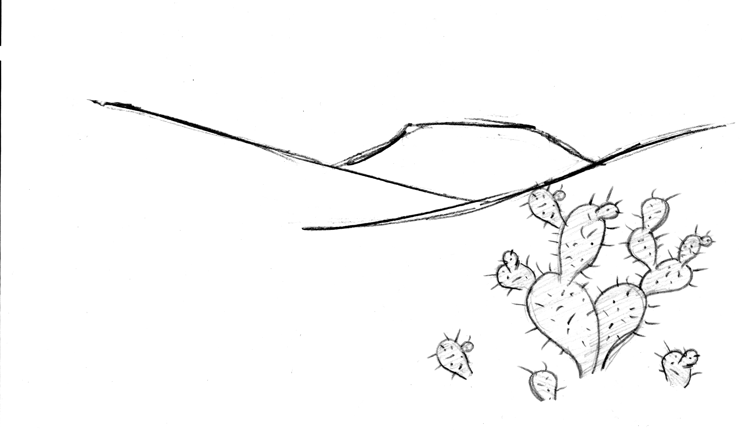
4
3
2
1

Recall that the three conditions listed below are necessary for natural selection to take place.

- Variation in characteristics within the population: In picture 1, what is the main difference between the cactus on the left and the cactus on the right?

- Differences in fitness (survival and reproduction): Why would a deer be more likely to eat the cactus on the left than the cactus on the right?

What effect does the deer's behavior have on the survival and reproduction of these two types of cactus?

