Honors Biology Name: _____________________
NDHS Date: ______________________
Enzymes and Metabolism
________________: sum of all chemical reactions in a cell
Parts of a Chemical Reaction:
________________ ________________
Examples: _________________________
Two types of Metabolism:
_____________: Reactions that
Called Reactions
Example:
: Reactions that
Called Reactions
Example: =
All Chemical Reactions Need to start =
Reactions that have enough energy to start at room temperature are called
Reactions that don’t have enough energy to start at room temperature are call .

Energy Profile of a Chemical Reaction
Key: E = amount of Energy
t = time
Ea = Activation Energy
Exothermic Reaction:
The products have than the reactants =
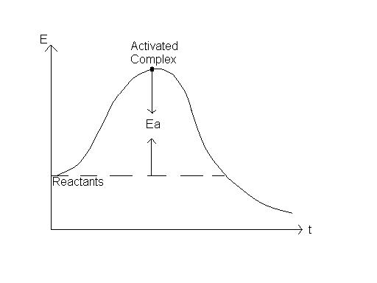
Change in Energy
Products
Endothermic Reaction:
The products have than the reactants = energy is
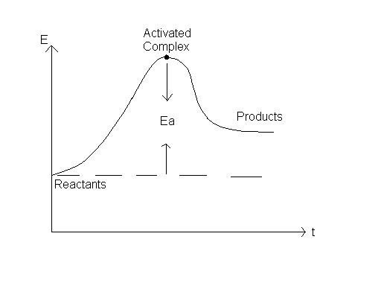
Change in Energy

Role of Enzymes:
Enzymes are .
Enzymes Lower the
- Give a for reactions
- Reactions happen
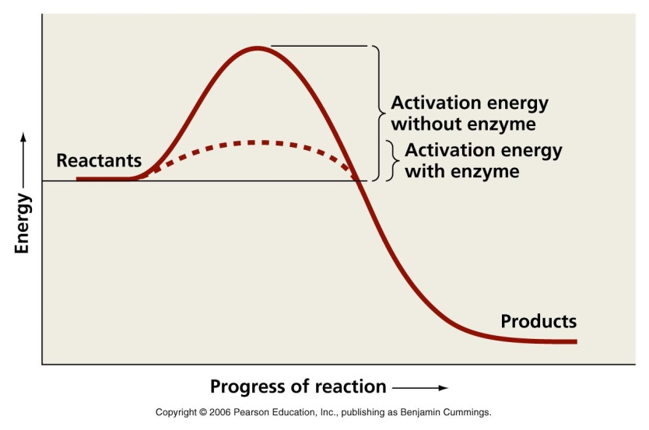
Enzymes are structures that bind to ____________________ and cause them to .
Substrates fit into the of the enzyme called the and cause the enzyme to – called a .
EX: Putting your hand in a glove.
The enzyme-substrate complex (when the two are bound together) create a that allows the reaction to happen faster. 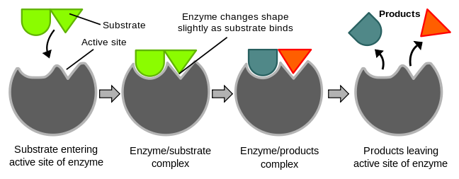
Factors that Affect Enzymes:
1) :
Increase in temperature a reaction because it provides more energy and makes the molecules collide faster.
HOWEVER, if the temperature
: to the chemical structure of a molecule –
Ex: Cooking an egg, having a fever
2) – all enzymes work best at a specific pH –
Most work best between .
Some work better in acidic conditions and some in basic.
If the pH is the enzyme will and stop working.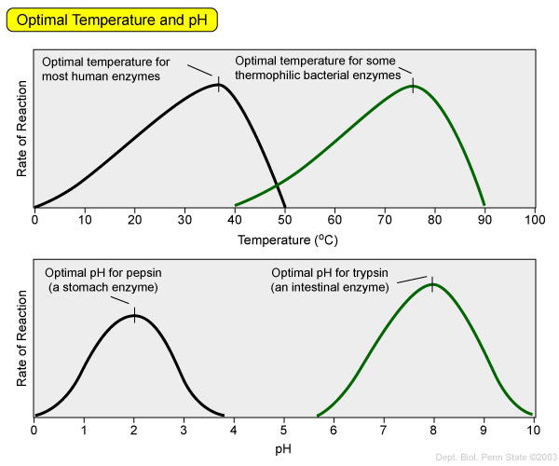
3)
If you have and you , the reaction will go .
If you have and increase the amount of , the reaction will go until you reach the point of ___________________________ and the enzymes are working at ____. Adding more substrate will not make the reaction go any faster.
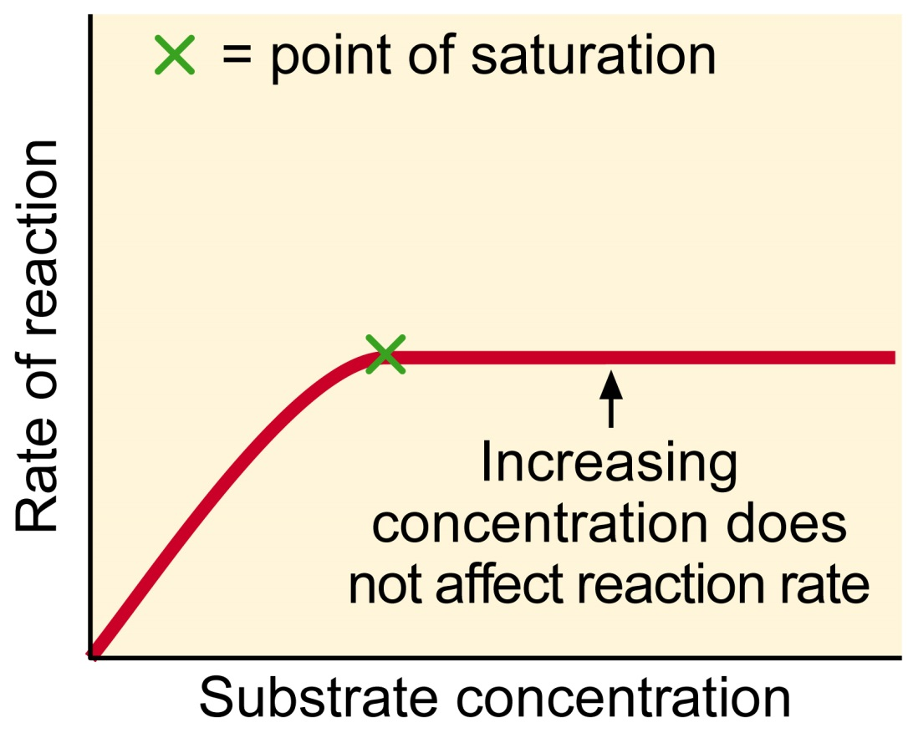
4)
Substances that to enzymes and
Co-factor =
Ex: in hemoglobin
in DNA polymerase (builds new DNA)
Co-enzyme =
Ex: Riboflavin (B₂) and Niacin (B₃) for components in cellular respiration =
5) ______________: Substances that bind to the enzyme and ________________.
Types:
1) ___________________: Bind to the ___________ and ___________ _________________________
2) _____________________: Bind to ________________ of the enzyme ___________________________________________________ (change in shape) so the ____________________
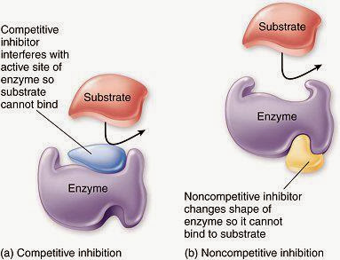

6)
Some enzymes and metabolic pathways (a series of several enzymatic reactions) are .
When , excess product
This keeps the cell from making too much of one product and
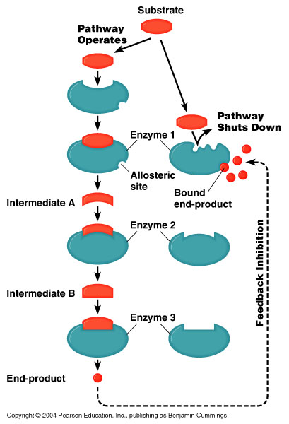
ARE ENZYMES IMPORTANT?
!!!!!YES!!!!!
They control that happens inside your cells.
___________________________

