Honors Biology Name: _____________________
NDHS Date: ______________________
Enzymes and Metabolism
Metabolism: sum of all chemical reactions in a cell
Parts of a Chemical Reaction:
Reactants Products
Examples: 2 H₂ + O₂ 2 H₂O
Two types of Metabolism:
Catabolism: Reactions that break down molecules and release energy
Called Exothermic or Exergonic Reactions
Example: CH₄ +2 O₂ CO₂ + 2 H₂O
Anabolism: Reactions that build molecules and store energy
Called Endothermic or Endergonic Reactions
Example: 6 CO₂ + 6 H₂O C₆H₁₂O₆ + 6 O₂ = photosynthesis
All Chemical Reactions Need Energy to start = Activation Energy
Reactions that have enough energy to start at room temperature are called Spontaneous
Reactions that don’t have enough energy to start at room temperature are call Non-Spontaneous.

Energy Profile of a Chemical Reaction
Key: E = amount of Energy
t = time
Ea = Activation Energy
Exothermic Reaction:
The products have less energy than the reactants = energy is given off
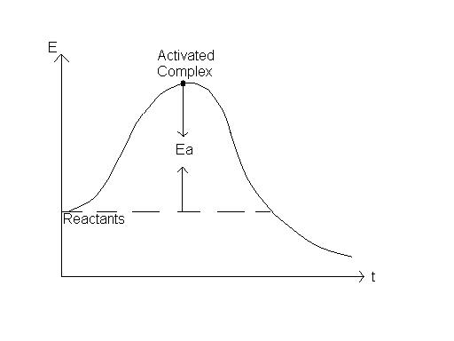
Change in Energy
Products
Endothermic Reaction:
The products have more energy than the reactants = energy is stored in chemical bonds
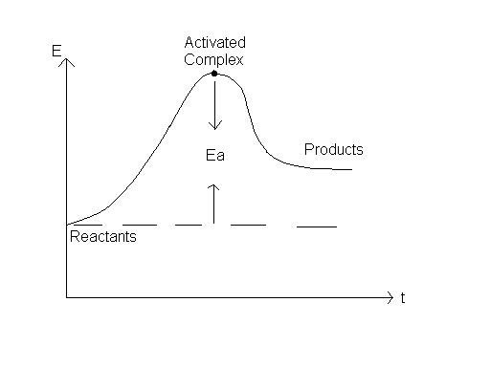
Change in Energy

Role of Enzymes:
Enzymes are Protein Catalysts.
Enzymes Lower the Activation energy
- Give a short cut for reactions
- Reactions happen faster and at a lower temperatures
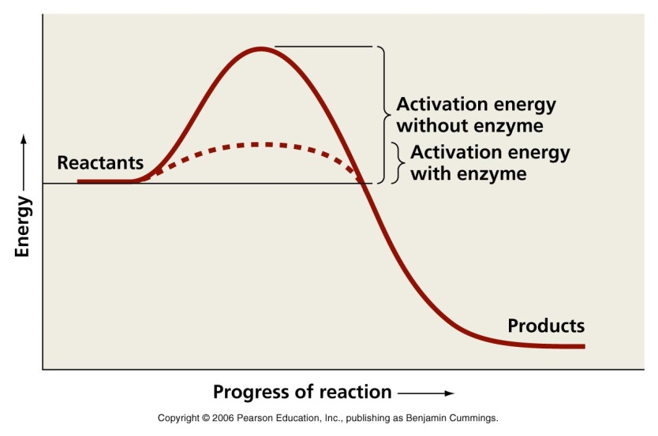
Enzymes are three dimensional structures that bind to chemicals called substrates and cause them to react faster.
Substrates fit specifically into the reaction center of the enzyme called the ACTIVE SITE and cause the enzyme to change shape slightly – called a conformational change or an INDUCED FIT.
EX: Putting your hand in a glove.
The enzyme-substrate complex (when the two are bound together) create a special environment that allows the reaction to happen faster. 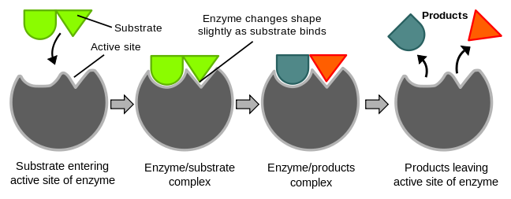
Factors that Affect Enzymes:
1) Temperature:
Increase in temperature speeds up a reaction because it provides more energy and makes the molecules collide faster.
HOWEVER, if the temperature increases too much, the enzyme DENATURES and no longer functions
Denature: to undo the chemical structure of a molecule – break it down
Ex: Cooking an egg, having a fever
2) pH – all enzymes work best at a specific pH – Optimal pH
Most work best between 6 – 8 .
Some work better in acidic conditions and some in basic.
If the pH is too high or too low the enzyme will denature and stop working.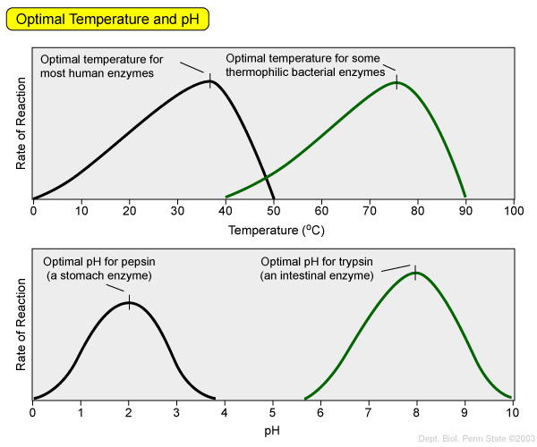
3) Enzyme and Substrate Concentrations
If you have lots of substrate and you increase the number of enzymes, the reaction will go faster until the level of substrate gets too low.
If you have lots of enzymes and increase the amount of substrate, the reaction will go faster until you reach the point of Enzyme Saturation and the enzymes are working at full capacity. Adding more substrate will not make the reaction go any faster.
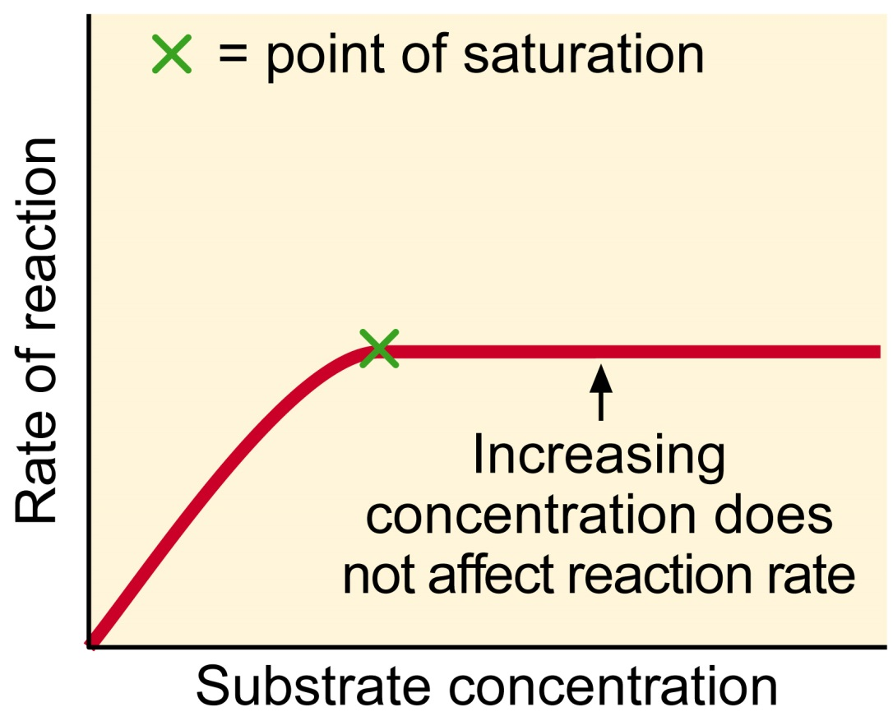
4) Presence of Co-factors and Co-enzymes
Substances that bind to enzymes and make them work properly
Co-factor = metal ions
Ex: Iron in hemoglobin
Zinc in DNA polymerase (builds new DNA)
Co-enzyme = vitamins
Ex: Riboflavin (B₂) and Niacin (B₃) for components in cellular respiration = energy production
5) Inhibitors: Substances that bind to the enzyme and stop it functioning.
Types:
1) Competitive Inhibitors: Bind to the active site and COMPETE with the substrate
2) Non-competitive Inhibitors: Bind to another area of the enzyme causing the active site to undergo a conformational change (change in shape) so the substrate can’t bind
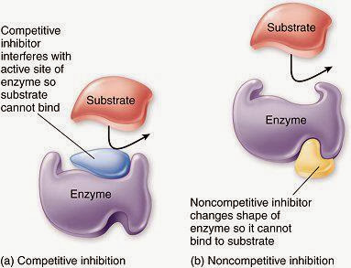
6) Regulatory Feedback
Some enzymes and metabolic pathways (a series of several enzymatic reactions) are regulated by the products of the reaction.
When enough product is made, excess product binds to the enzyme and turns it off.
This keeps the cell from making too much of one product and wasting energy and resources.
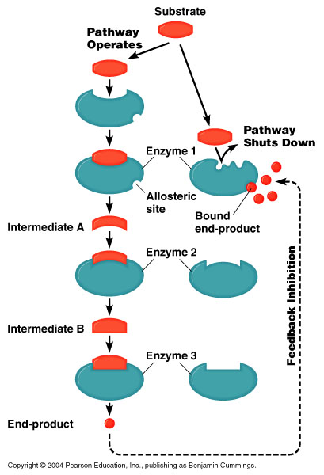
ARE ENZYMES IMPORTANT?
!!!!!YES!!!!!
They control EVERYTHING that happens inside your cells.
No enzymes = No Life.

