Honors Biology Name: _________________________
NDHS Per: _________ Date: ____________
DNA Structure
Genetics and Heredity: the study of the inheritance of genes, genotypes, and phenotypes of individuals and populations.
Gene: Section of DNA that by directing the .
Protein is then used as the materials to OR it is an .
The expression of these proteins is what .
EX: Skin color is due to the presence of melanin in the skin. The genes tell the cell how much melanin to make. The more “dark genes” causes more melanin to be produced making the skin darker.
The structure of each gene is based on its .
Structure of DNA:
DNA =
– a
Components of DNA:
Base unit =
Composition:
1. 2.
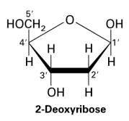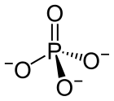

3.
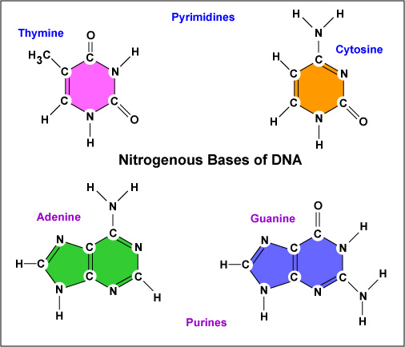
DNA Molecule Structure
- Discovered by using ( ) the work of
What they found:
_________ of “ladder” are made of .
Phosphates bind to the ______________________________________.
________ of the “ladder” are made of
Bases .
Each side runs to the other – they run

