Honors Biology Name: _________________________
NDHS Per: _______ Date: _______________

Human Digestive System
Label the following diagram and complete the chart. 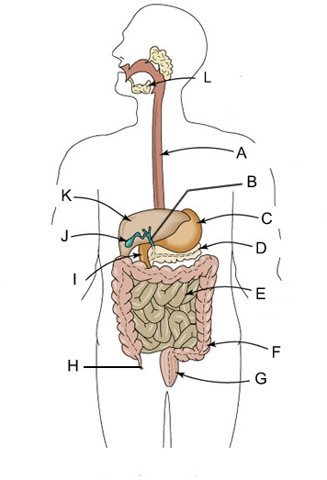
1. ______________________
2. ______________________
3. ______________________
4. ______________________
5. ______________________
6. ______________________
7. ______________________
8. ______________________
9. ______________________
10. _____________________
11. _____________________
12. _____________________

12.
11.
10.
9.
8.
7.
6.
5.
4.
3.
2.
1.
Organ, Structure, or Enzyme | Function
Mouth
Teeth
Saliva
Salivary Amylase
Esophagus
Cardiac Sphincter
Stomach
Pepsin
Pyloric Sphincter
Duodenum
Pancreas
Pancreatic Amylase
Trypsin, Peptidase
Lipase
Maltase, Sucrase, Lactase
Liver and Gall Bladder
Bile
Jejunum and Ileum
- Villi and Microvilli
Large Intestine
Appendix
Rectum and Anus

