Honors Biology Name: ________________________  
NDHS Per: ________ Date: ____________

**Cladograms  
Tree of Life**

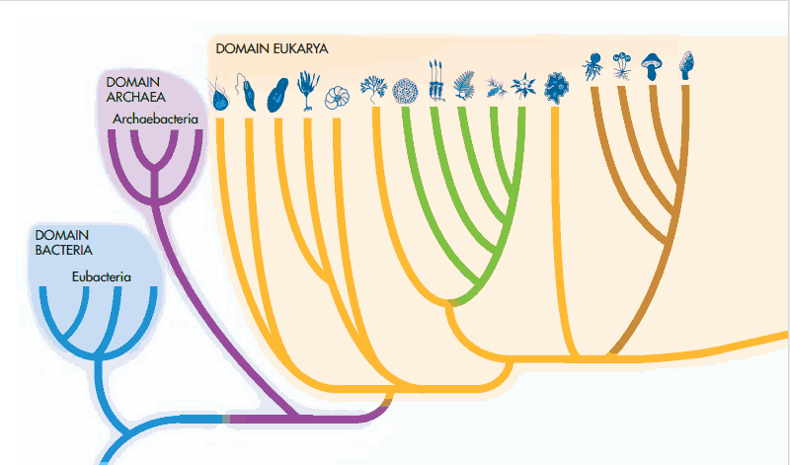

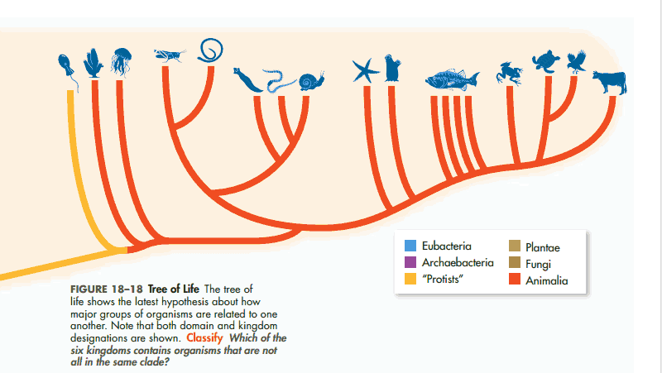

**Cladogram:**

* Pictorial representation of the  that are reflected in
* Each branch is called a  and represents a  that lead to the
* The point where they split is called a  and represents that last point where they had a
* The  two species are on a cladogram, the

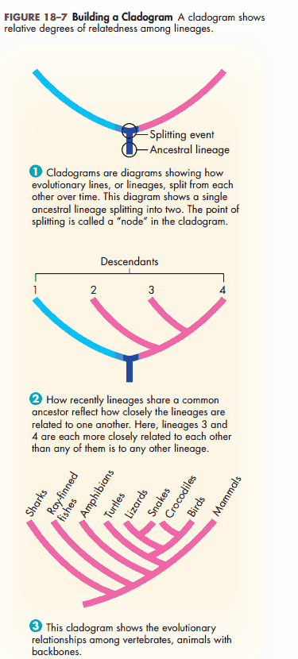

A “” event is some evolutionary change that occurs and results in the  **________________________**

New characteristics are called **_______________________**_

Characteristics that are common among several branches are called   
**________________________**

**Interpreting a Cladogram**

1. Which species is the outgroup?

1. After which animals did mammary glands develop?

1. What animal does not have jaws?

1. Which animals have lungs?

1. What is the derived character that separates salamanders and lizards?

1. What is a shared character between pigeons and lizards?

1. Based on the cladogram, which shared a common ancestor most recently- a mouse and a lizard, or a mouse and a perch?

**Making a Cladogram:**

1. Gather information about species and make a chart. Make a “+” if they have the trait or a “–“ if they don’t.

|  |  |  |  |  |  |
| --- | --- | --- | --- | --- | --- |
| Organism | Adults Breath  With Lungs | Amniotic Egg (Protected) | Hair | Specialized Teeth for Eating Meat | Retractable Claws |
| Fish |  |  |  |  |  |
| Frog |  |  |  |  |  |
| Lizard |  |  |  |  |  |
| Kangaroo |  |  |  |  |  |
| Dog |  |  |  |  |  |
| Cat |  |  |  |  |  |

1. Draw a  with the most . Add concentric circles to the middle indicating the .
2. Draw a . Wherever the Venn Diagram gets more specific, draw a ________________________ and label the organism that branches at that point.

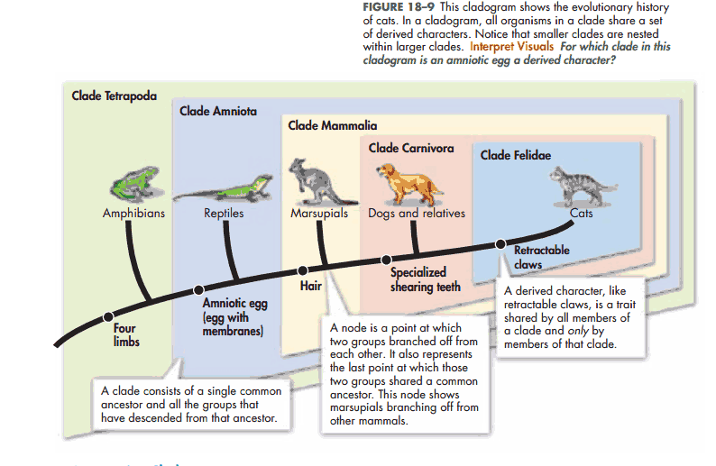

**Additional Practice:**

|  |  |  |  |  |
| --- | --- | --- | --- | --- |
|  | Hair | Legs | Thumbs | eyes |
| Human |  |  |  |  |
| Snake |  |  |  |  |
| Monkey |  |  |  |  |
| Mouse |  |  |  |  |
| Starfish |  |  |  |  |

**Make your own using the following organisms.**

|  |  |  |  |  |  |
| --- | --- | --- | --- | --- | --- |
| Organism |  |  |  |  |  |
| Bacteria |  |  |  |  |  |
| Fungus |  |  |  |  |  |
| Plant |  |  |  |  |  |
| Insect |  |  |  |  |  |
| Octopus |  |  |  |  |  |