Honors Biology Name: ________________________
NDHS Per: __________ Date: ___________

Cellular Respiration
Respiration = to breathe
Breathing at the cellular level
Purpose: to generate ATP for cellular work by transferring the energy trapped in food molecules
HOW: Food molecules are broken down and the energy released as energyized electrons is captured and transferred to make ATP
Uses Hydrogen Acceptors:
NAD+ – nicotinamide adenine dinucleotide
FAD – flavin adenine dinucleotide
Types of Cellular Respiration:
Aerobic – uses oxygen and requires mitochondria – in Eukaryotic cells
Anaerobic – does not use oxygen and occurs in the cytoplasm – in Prokaryotes and Eukaryotes
Structure of the Mitochondria:
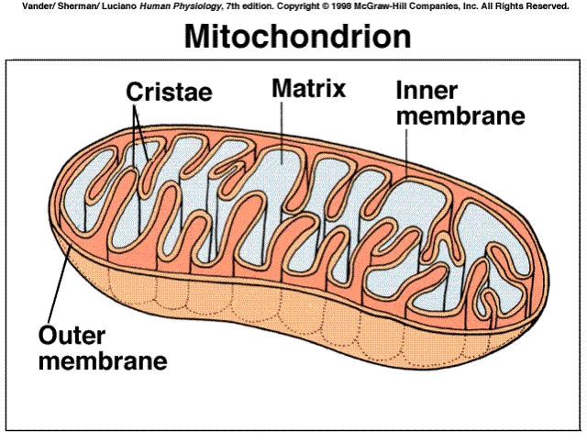
Cellular Respiration Equation:
C₆H₁₂O₆ + 6 O₂ 6 H₂O + 6 CO₂
Steps of Cellular Respiration:
1. Glycolysis: Glucose is split in half – same as anaerobic respiration
- occurs in cytoplasm
2. _{Krebs} Cycle:
- products of glycolysis are broken down releasing CO2 and transferring electrons and hydrogens to NAD+ and FAD
- occurs in matrix of mitochondria
3. Oxidative Phosphorylation (Electron Transport Chain):
- energized electrons are used to make a hydrogen gradient to make ATP
- occurs in the inner membrane and intermembranous space of the mitochondria
GLYCOLYSIS: THE DETAILS:
Two Parts:
1) Energy Investment Stage:
2 ATP molecules are used to energize a glucose molecule
This makes it unstable and it breaks apart into two, 3 Carbon molecules.
2) Energy Payoff Stage:
The phosphates from the 3 carbon molecules are used to make 4 ATP.
Two NAD+ gain electrons and hydrogens to make 2 NADH.
The end products are 2, 3 Carbon molecules called Pyruvate.

Reactants | Products
Glucose  2 ATP  2 NAD+ | 2 Pyruvate – go to _{Krebs} Cycle  4 ATP (Net of 2)  2 NADH – go to ETC

_{Krebs} Cycle:
Occurs in the Matrix of the Mitochondria
Everything in the _{Krebs} Cycle happens twice because there are two pyruvates from glycolysis.
- Pyruvate enters the mitochondria and immediately loses a CO₂ and makes a NADH forming acetic acid which binds to an enzyme called Co-enzyme A.
CO₂
NAD+
NADH

Pyruvate Acetic Acid + Coenzyme A Acetyl CoA

- Acetic CoA bonds with a 4 carbon compound called oxaloacetate to make Citric Acid (_{Krebs} is also called the Citric Acid Cycle)
- Citric undergoes many changes and releases 2 CO₂ molecules, 1 ATP, and 3 NADHs and 1 FADH₂.
- At the end the 4 carbon compound, oxaloacetate, is remade = cycle.

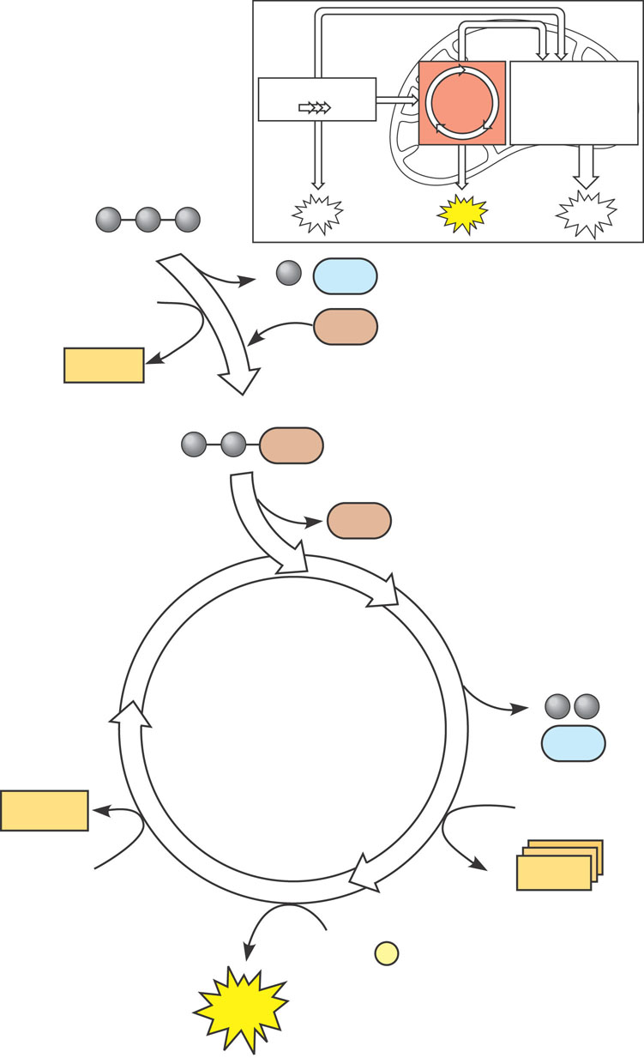
ATP
2 CO₂
3 NAD⁺
3 NADH
+ 3 H⁺
ADP + P _{i}
FAD
FADH₂
Citric
acid
cycle
CoA
CoA
Acetyle CoA
NADH
+ 3 H⁺
CoA
CO₂
Pyruvate
(from glycolysis,
2 molecules per glucose)
ATP
ATP
ATP
Glycolysis
Citric
acid
cycle
Oxidative
phosphorylation

Reactants | Products
2 Pyruvate  8 NAD+  2 FAD  2 ADP  2 Phosphates | 6 CO2  8 NADH  2 FADH2  2 ATP

Electron Transport Chain:
Where: Inner membrane, Matrix, and Intermembranous Space
What Happens:
Energized electrons from NADH and FADH2 enter the ETC and pump Hydrogen ions into the intermembranous space.
Hydrogen ions pass through ATP Synthase to make ATP.
Electrons pass from the ETC to Oxygen which then combines with Hydrogen ions to make water.
The whole process is called Chemiosmotic Phosphorylation.
Chemiosmosis = osmosis of chemicals
Phosphorylation = adding phosphates

Intermembranous Space
Matrix
NADH
NAD+ + H+
FAD + 2 H+
FAD
e-
e-
e- + 2 H₂O
O₂ + 4 H+ +
H+ ions
H+ ions
H+ ions
H+ ions
H+ ions
H+ ions
H+ ions
H+ ions
H+ ions
H+ ions
H+ ions
H+ ions
ADP + P
ATP

H+ ions

ATP Yields:
Each NADH = 3 ATP
Each FADH2 = 2 ATP
Totals: 10 NADH x 3 = 30 ATP
2 FADH2 x2 = 4 ATP
Total = 34 ATP
Reactants | Products
10 NADH  2 FADH2  ADP + Phosphate  Oxygen  Hydrogen Ions | 10 NAD+  2 FAD  34 ATP  H₂O

Total Energy Yield for 1 Glucose:
Glycolysis = 2 ATP
_{Krebs} Cycle = 2 ATP
ETC = 34 ATP
Total = 38 ATP

Anaerobic Respiration
Prokaryotes just use glycolysis. Each glucose yields 2 ATP.
Eukaryotes use Aerobic Respiration unless the cells become starved of oxygen.
Lack of oxygen shifts metabolism from aerobic respiration to fermentation (anaerobic).
This is done to keep the cell alive until oxygen is restored.

Types of Fermentation:
Alcoholic Fermentation: Yeast cells
Cells take pyruvate and remove a CO₂ molecule making acetic anhydride.
NADH is used to convert the acetic acid into ethyl alcohol and NAD+.
The NAD+ can be used in glycolysis to make ATP keeping the cell alive.
Reactants | Products
Pyruvate  NADH | Ethanol  NAD+  CO₂

Lactic Acid Fermentation: Muscle Cells
Pyruvate uses NADH to make lactic acid and NAD+
NAD+ is used in glycolysis to make ATP.
Lactic acid causes the muscles to burn, slowing you down, allowing more oxygen to get to the cells.
Reactants | Products
Pyruvate  NADH | Lactic Acid  NAD+

