Honors Biology Name: _______________________
NDHS Per: _______ Date: _____________
Calories In Food
The Calories in food tells us how much energy is contained in what we are eating. The root word “calor” actually means “Heat”.
To determine the caloric value of a food, the food is burned and the amount of heat that is given off tells us how much energy is in the food. Therefore the number of Calories in food is how much heat it gives off when burned.
Different types of biological molecules have different caloric values.
Proteins have 4 Calories per gram
Carbohydrates have 4 Calories per gram
Lipids (fats and oils) have 9 Calories per gram
EX. If you have a piece of candy that has 10.0 grams of sugar (carbohydrate) then you determine the total number of Calories by multiplying the number of grams by 4.
10.0 grams of carbohydrdrates
4 Calories
= 40 Calories
Gram of Carbohydrate

If you look at this set up, the horizontal line acts as a fraction line making the top the numerator and the bottom the denominator. Anything in the top is multiplied and anything in the bottom (the denominator) is divided. As you can see the labels (units) of “grams of carbohydrate” is both in the numerator and the denominator. Therefore these units cancel (Just like dividing a number by itself). Then you multiply the 10.0 X 4 and the unit left over is Calories.
Problems: SHOW YOUR WORK!!!
- How many Calories are in 15.0 grams of protein?

- How many Calories are in 12.0 grams of fat?
- What has more Calories, 20.0 grams of carbohydrates or 9 grams of fat?
- If a piece of margarine is 100% fat and has 135 Calories, how many grams is it?
The following is a nutrition label from a popular candy bar. Using the grams of fat, carbohydrates, and protein, calculate the number of Calories in the candy bar. Show your work.
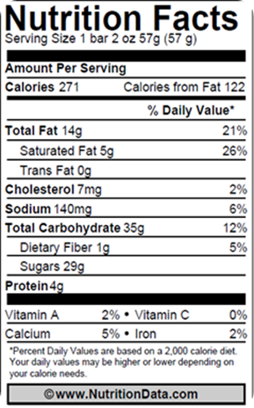
Total Calories = ___________________
Knowing the total Calories, calculate the percentage of each type of nutrient in each serving of food.
Remember: Percentage is the part divided by the total X 100
Show your work
Fat:
Carbohydrates:
Proteins:

If a “diet” food, is very low in fat, it still might not help you lose weight. Explain.

