Honors Biology Name: ____________________
NDHS Date: _____________________

Diversity of Life: Prokaryotes and Viruses

Pro. vs. Eu.
Prokaryotic:
- “no” nucleus = nucleoid – simple, circular genome + plasmids
- unicellular
Eukaryotic:
- “true” nucleus
- unicellular and multicellular

Structure
Shape:
- round
- rod
– helix
Colony Types:
= chains
= cluster

Cell Wall Composition
Bacterial Wall Structure: Archae Wall Structure:

Gram Negative Wall
Trouble for the Infected
1. Outer Membrane Contains
- Can be
2. Outer Membrane “ ” bacteria from
3. Outer Membrane gives
– impedes transport of antibiotic into the cell

RESULT: Identify Bacteria to determine treatment

Classification of Prokaryotes:
Based on Signature Sequences of rRNA and Nucleic Acids

Archaea: the

Types:
Methanogens

- live in
- use
- Location:

- ( – – help digest large quantities of )

Extreme Halophiles
- salt lovers
- Live in very – up to more than sea water
- Form a
– due to ( )

Extreme Thermophiles

- Live in very warm environments ( )
- Ex.

Bacteria: most common type of prokaryote

Types:
Oodles – classification based on structure and metabolism

Ecological Roles of Prokaryotes

= decomposers
= absorb nutrients from body fluids of living hosts
=
- key to
- fix atmospheric nitrogen (N₂) into ammonia (NH₃) for uptake by plants

converting NH₃, NO₂⁻ or NO₃⁻ to

: photosynthetic bacteria –

: Methanogens: guts of termites and cows
Root nodules of Legumes for nitrogen fixation

Prokaryotes in Research and Technology
: cheese and yogurt
: using a living organism to clean the environment
Ex: decompose sewage, breakdown radioactive waste and oil spills
: ore refining
Ex: remove copper from copper sulfides, extract gold from ore
:
Ex: produce vitamins, antibiotics, hormones, gene cloning

VIRUSES:

Common Characteristics:
-
-
-
Optional Upgrades:

Results due to mode of

Viral Infection Patterns:

1.
2.
3.

Lytic Cyle:
- Virus attaches to _________.
- Virus injects _____ into host.
- Viral DNA _________________________________ and make components for protein shell.
- Viral parts assemble until the host cell ________________ ___________new viruses.
Lysogenic Cycle:
- Virus attaches to host and injects DNA.
- Viral DNA ________________ into the host DNA.
- Host reproduces normally while replicating the viral DNA at the same time.
- Something triggers the viral DNA to leave the host DNA triggering the lytic cycle.

Enveloped Viruses
Envelope is a with surface that

If the binding proteins are then the virus
. Thus, since different species have different surface proteins, unless two species share common surface proteins.
Enveloped Virus Cycle:

- Virus envelope binds to surface of host cell’s membrane.
- ____________________ with the host’s membrane and dumps _______
____________________________________________________________
- Host cell __________________ of the viral genome, capsid proteins and glycoproteins.
- Viral components assemble ____________________________ exocytosis ____________________________________________________________.

EXAMPLE: Influenza

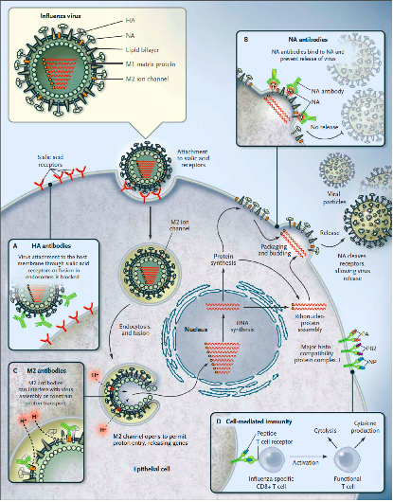

VIRAL CLASSIFICATION:
Based on type of nucleic acids
: double or single stranded
: double or single stranded
- Further classification is based on what the
- May act as mRNA, a template for mRNA or a
Last type manufactures an enzyme called
and is called a
Ex:

ANTIBIOTICS treat ________________________.

They DO NOT treat _________________.

